SEASONAL CUES AND DIAPAUSE PREPARATION IN THE EUROPEAN CORN BORER, *Ostrinia nubilalis* (LEPIDOPTERA: CRAMBIDAE)

By

JAMES T. BROWN

A THESIS PRESENTED TO THE GRADUATE SCHOOL OF THE UNIVERSITY OF FLORIDA IN PARTIAL FULFILLMENT OF THE REQUIREMENTS FOR THE DEGREE OF MASTER OF SCIENCE

UNIVERSITY OF FLORIDA

2018

*⃝*c 2018 James T. Brown

To my family

ACKNOWLEDGMENTS

I thank my major adviser Dr. Daniel Hahn for supporting my research and professional development, and my committee members Dr. John Beck and Dr. Robert Meagher for their pragmatism and unique perspectives. I also thank Qinwen Xia-Chen, Chao Chen, Nausheena Baig, and Caitlin Rering for their assistance with experimental design, Andrew Nguyen for his assistance with data analysis, and Dr. Charles Stuhl, Leigh Boardman, Clancy Short, and Dylan Tussey for stimulating my intellect and inspiring ideas. I also thank the Entomology and Nematology Department of the University of Florida and the United States Department of Agriculture, Agricultural Research Services, Center for Medical, Agricultural, and Veterinary Entomology (USDA-ARS CMAVE) for supporting me financially during my degree program. Finally, I thank every student in the Entomology and Nematology Student Organization for their friendship and support.

4

|  |  |
| --- | --- |
| TABLE OF CONTENTS |  |
|  | page |
| ACKNOWLEDGMENTS . . . . . . . . . . . . . . . . . . . . . . . . . . . . . . . . . . . | 4 |
| LIST OF TABLES . . . . . . . . . . . . . . . . . . . . . . . . . . . . . . . . . . . . . . | 6 |
| LIST OF FIGURES . . . . . . . . . . . . . . . . . . . . . . . . . . . . . . . . . . . . . | 7 |
| ABSTRACT . . . . . . . . . . . . . . . . . . . . . . . . . . . . . . . . . . . . . . . . . | 8 |
| CHAPTER |  |

* INTRODUCTION . . . . . . . . . . . . . . . . . . . . . . . . . . . . . . . . . . . 10

2 The European Corn Borer, *Ostrinia nubilalis* (LEPIDOPTERA CRAMBIDAE) . . . 14

|  |  |  |  |  |
| --- | --- | --- | --- | --- |
|  | 2.1 | Phylogeny of *Ostrinia nubilalis* . . . . . . . . . . . . . . . . . . . . . . . . . | | 15 |
|  | 2.2 | Life History of *Ostrinia nubilalis* . . . . . . . . . . . . . . . . . . . . . . . . . | | 18 |
| 3 | European Corn Borer: The relationship between stored resources and diapause timing | | | 21 |
|  | 3.1 | Introduction . . . . . . . . . . . . . . . . . . . . . . . . . . . . . . . . . . . | | 21 |
|  | 3.2 | Methods . . . . . . . . . . . . . . . . . . . . . . . . . . . . . . . . . . . . . | | 30 |
|  |  | 3.2.1 | General Rearing . . . . . . . . . . . . . . . . . . . . . . . . . . . . . . | 30 |
|  |  | 3.2.2 | Experiment 1: Estimating the Onset Diapause and Classifying Diapause |  |
|  |  |  | Programmed Larvae Using Metabolic Activity . . . . . . . . . . . . . . | 31 |
|  |  | 3.2.3 | Experiment 2: A Wandering Assay to Mark Diapause Initiation Timing |  |
|  |  |  | and Estimate Stored Lipids . . . . . . . . . . . . . . . . . . . . . . . . | 34 |
|  |  | 3.2.4 | Statistical Analyses . . . . . . . . . . . . . . . . . . . . . . . . . . . . | 36 |
|  | 3.3 | Results . . . . . . . . . . . . . . . . . . . . . . . . . . . . . . . . . . . . . . | | 36 |
|  |  | 3.3.1 | Experiment 1: Metabolic Activity . . . . . . . . . . . . . . . . . . . . | 36 |
|  |  | 3.3.2 | Experiment 2: Stored Lipids . . . . . . . . . . . . . . . . . . . . . . . | 38 |
|  | 3.4 | Discussion . . . . . . . . . . . . . . . . . . . . . . . . . . . . . . . . . . . . | | 39 |
|  |  | 3.4.1 | The Relationship Between Diapause Genotype and Nutrient Storage . . | 39 |
| LIST OF REFERENCES . . . . . . . . . . . . . . . . . . . . . . . . . . . . . . . . . . . | | | | 59 |
| BIOGRAPHICAL SKETCH . . . . . . . . . . . . . . . . . . . . . . . . . . . . . . . . . | | | | 64 |

5

|  |  |  |
| --- | --- | --- |
|  | LIST OF TABLES |  |
| Table |  | page |
| 2-1 | Subgroups of *Ostrinia* uncus group III using mid-tibiae length . . . . . . . . . . . . | 20 |
| 3-1 Comparing CO2 production between individuals reared in diapause programming | |  |
|  | and non-diapause conditions. . . . . . . . . . . . . . . . . . . . . . . . . . . . . . | 54 |
| 3-2 Model selection by factor elimination for lean mass accumulation prior to the | |  |
|  | onset of diapause . . . . . . . . . . . . . . . . . . . . . . . . . . . . . . . . . . . | 55 |
| 3-3 Linear mixed eﬀects model comparison of lean mass accumulation between diapause | |  |
|  | genotypes before the onset of diapause . . . . . . . . . . . . . . . . . . . . . . . . | 55 |
| 3-4 Model selection by factor elimination for lipid mass accumulation prior to the onset | |  |
|  | of diapause . . . . . . . . . . . . . . . . . . . . . . . . . . . . . . . . . . . . . . . | 56 |
| 3-5 Linear mixed eﬀects model comparison of lipid mass accumulation between genotypes | |  |
|  | before the onset of diapause . . . . . . . . . . . . . . . . . . . . . . . . . . . . . . | 56 |
| 3-6 | Model selection by factor elimination for lean mass depletion during diapause . . . . | 57 |
| 3-7 | Comparing lean mass depletion between diapause genotypes during diapause . . . . | 57 |
| 3-8 | Model selection by factor elimination for lipid mass depletion during diapause . . . . | 58 |
| 3-9 | Comparing lipid mass depletion between diapause genotypes during diapause . . . . | 58 |

6

|  |  |  |  |
| --- | --- | --- | --- |
|  |  | LIST OF FIGURES |  |
| Figure | |  | page |
| 1-1 Predictive graph of the relationship between nutrition stores and diapause genotype. | | | 13 |
| 3-1 | Observations of larvae in diapause programming conditions . . . . . . . . . . . . . | | 45 |
| 3-2 Wandering assay tray . . . . . . . . . . . . . . . . . . . . . . . . . . . . . . . . . | | | 46 |
| 3-3 Distribution of larvae entering the wandering stage . . . . . . . . . . . . . . . . . . | | | 47 |
| 3-4 Accumulation of wet mass among larvae in diapause programming and non-diapause | | |  |
|  | conditions. . . . . . . . . . . . . . . . . . . . . . . . . . . . . . . . . . . . . . . . | | 48 |
| 3-5 Comparing CO2 production between larvae with diﬀerent diapause genotypes when | | |  |
|  | reared under the same photoperiod . . . . . . . . . . . . . . . . . . . . . . . . . . | | 49 |
| 3-6 Comparing CO2 production between larvae with the same diapause genotype when | | |  |
|  | reared in diﬀerent photoperiods . . . . . . . . . . . . . . . . . . . . . . . . . . . . | | 50 |
| 3-7 | Comparing CO2 production between shallow diapause and deep diapause larvae with | |  |
|  | the short-diapause genotype . . . . . . . . . . . . . . . . . . . . . . . . . . . . . . | | 51 |
| 3-8 | The eﬀect of diapause programming on lean mass and lipid mass accumulation prior | |  |
|  | to the onset of diapause . . . . . . . . . . . . . . . . . . . . . . . . . . . . . . . . | | 52 |
| 3-9 | The eﬀect of diapause programming on lean mass and lipid mass depletion during | |  |
|  | diapause . . . . . . . . . . . . . . . . . . . . . . . . . . . . . . . . . . . . . . . . | | 53 |

7

Abstract of Thesis Presented to the Graduate School of the University of Florida in Partial Ful llment of the Requirements for the Degree of Master of Science

SEASONAL CUES AND DIAPAUSE PREPARATION IN THE EUROPEAN CORN BORER, *Ostrinia nubilalis* (LEPIDOPTERA: CRAMBIDAE)

By

James T. Brown

December 2018

Chair: Daniel A. Hahn

Major: Entomology and Nematology

Many ectotherms respond to seasonal abiotic stress in their environment using seasonal dormancy. Insects in temperate regions use diapause to avoid low winter temperatures and synchronize their life histories with the warm growing season. Diapause is genetically programmed seasonal dormancy that is initiated before the onset of winter and that can have sweeping effects on an insect's metabolism and development. During winter, low temperatures are accompanied by scarce sources of nutrition and many insects do not feed during this period. To meet their metabolic demands during diapause, insects often accumulate greater energy reserves before the onset of winter. Moreover, after diapause ends, some insects rely on that same resource pool of stored energy reserves to complete metamorphosis, find mates, and reproduce. Successful diapause entry and exit are crucial to the very survival of some insects. Studying diapause provides an opportunity to understand some of the ways nutritional stores are managed. Diapause is a common life history strategy used by many insects in temperate regions. However, how insects manage nutrition in preparation for diapause and during diapause remains obscure.

My goal was to determine the degree to which larval diapause genotype affects lipid accumulation in preparation for diapause and lipid depletion during diapause; specifically, I compared one strain with a long-diapause genotype and another with a short-diapause genotype. I predicted that diapause programming, and strain would have significant effects on lipid accumulation in preparation for diapause. European corn borer larvae use photoperiod as

8

a cue for diapause induction. As photoperiod becomes shorter and crosses a critical biological threshold it induces diapause phenology. I reared two strains of *Ostrinia nubilalis* (European corn borer) that diﬀer in diapause genotype under conditions that programmed diapause (12L:12D photoperiod, 23*◦*C, and 65% relatively humidity) and conditions that did not induce diapause (16L:8D photoperiod, 23*◦*C, and 65% relatively humidity). At the start of diapause, long-diapause genotype larvae stored signi cantly more lipids in preparation for diapause than individuals with the short diapause genotype. However, during the rst thirty days after diapause initiation, lipid depletion did not change signi cantly between each strain during the time points chosen.

In conclusion, the coupled eﬀects of diapause genotype and diapause programming on lipid accumulation seem clear; European corn borer nutrition stores increase with diapause programming and these stores increase proportionally more in the strain with a longer diapause. However, nutrition depletion during diapause may not follow the same pattern. Manipulating nutrition stores of these larvae before the onset of diapause could reduce energy available to fuel metabolic activity and result in mortality. Before lipid accumulation or lipid depletion

can be a target for pest management, more research must be done to better understand the relationship between nutrition management, diapause length, and overwintering survival.

9

CHAPTER 1

INTRODUCTION

What are the factors that aﬀect dormancy and life history timing? How do animals synchronize their life history with seasonal variation? To what degree does environmental variation alter phenotypes? In temperate regions, seasons cycle predictably between favorable spring and summer and unfavorable fall and winter. Winters in temperate regions are cold, dry, and nutrition is unavailable. Some insects in these regions have evolved seasonal dormancy (diapause) as a strategy to protect themselves from the unfavorable winter environment. Diapause is an alternative life history trajectory that is induced before the start of unfavorable conditions that leads to major physiological changes. There is substantial genetic variation in diapause-associated life history traits both within and among species. Variation in diapause traits may serve to synchronize insect life histories with predictable seasonal change. Genetic variation in diapause is also critical for diapause to evolve by natural selection. Climate change can lead to disruptions in diapause-mediated life history synchrony between insects and their environments as seasons become less predictable. Insects that are successful or are positively impacted by the warmer temperatures and longer growing seasons associated with climate change could be termed "winners" and insects that are negatively impacted by warming temperatures and shifting seasons could be termed "losers". Genetic variation in diapause traits could prove to be bene cial as climate changes and seasonality becomes less predictable.

In temperate regions, warm temperatures persist in the spring and summer. During the warm season, insects use available food and water to grow, develop, and reproduce. As temperatures decline in the fall and winter, resources become scarce. For insects in temperate regions, low temperatures can greatly reduce metabolic activity making continued activity challenging or even impossible. To overcome the challenges faced during winter, many temperate dwelling insects use diapause. Diapause is a genetically regulated and environmentally in uenced alternative developmental trajectory initiated before the onset of winter and during a species-speci c life stage (Kostal 2006). By monitoring environmentally

10

consistent cues that cycle with seasonality, insects can reliably predict, prepare for, and protect themselves from unfavorable changes in seasonal temperature and resource availability by initiating diapause. To predict seasonal change, temperate insects generally use photoperiod alone or in concert with other environmental cues, like temperature or host-plant quality, to induce diapause before arrival of prolonged seasonal stress.

The onset of diapause is generally marked by the suspension of development, a reduction in metabolic activity, and during diapause many insects do not feed (Tauber and Tauber 1981, Kostal 2006, Hahn and Denlinger 2007, Sinclair 2015). However, diapausing insects must continue to meet the energetic demands of their metabolism during diapause. In addition to the added energy cost incurred by surviving winter in diapause, insects exiting diapause must also have enough energetic and anabolic resources left to resume development.

In preparation for diapause many insects store additional lipids to use as fuel during diapause, however nutrition is also stored in the form of carbohydrates and proteins (Arrese 2010, Hahn and Denlinger 2007). The decision to switch developmental trajectories, timing the onset of diapause, levels of nutritional storage in preparation for diapause, and the rate that stored energy is depleted during diapause are each crucial to surviving diapause. If the onset of diapause occurs before the favorable season ends it will limit an insect’s ability to take advantage of available resources. Early entry into diapause could also lead to the premature depletion of stored nutrients as metabolic activity during diapause relies on stored energy. If the onset of diapause is late and occurs after the unfavorable season begins an insect could be exposed to conditions that could cause mortality.

The goal of this study is to characterize the relationship between nutrition storage and diapause genotype. Using two strains of *Ostrinia nubilalis* (European corn borer) with diﬀerent diapause genotypes, I tested the degree to which diapause genotype aﬀects nutrition storage. Speci cally, I tested the degree to which diapause genotype could be associated with lipid storage during diapause preparation in European corn borer. I expected insects with a longer diapause genotype to store more lipids than insects with a shorter diapause genotype in

11

preparation for diapause (1-1). When I programmed larvae for diapause and compared each diapause genotype, I found that larvae with a longer diapause genotype showed an increase in lipid storage in relation to individuals with the short-diapause genotype. I also sampled larvae during diapause, expecting no diﬀerence in lipid depletion between the longer diapausing genotype and the shorter diapausing genotype. I found similar lipid depletion rates between each diapause genotype but my data are too sparse to thoroughly assess this pattern. Whether the accumulation of other nutrient macromolecules, speci cally proteins and carbohydrates, follows the same pattern as lipid stores remains to be tested.

12

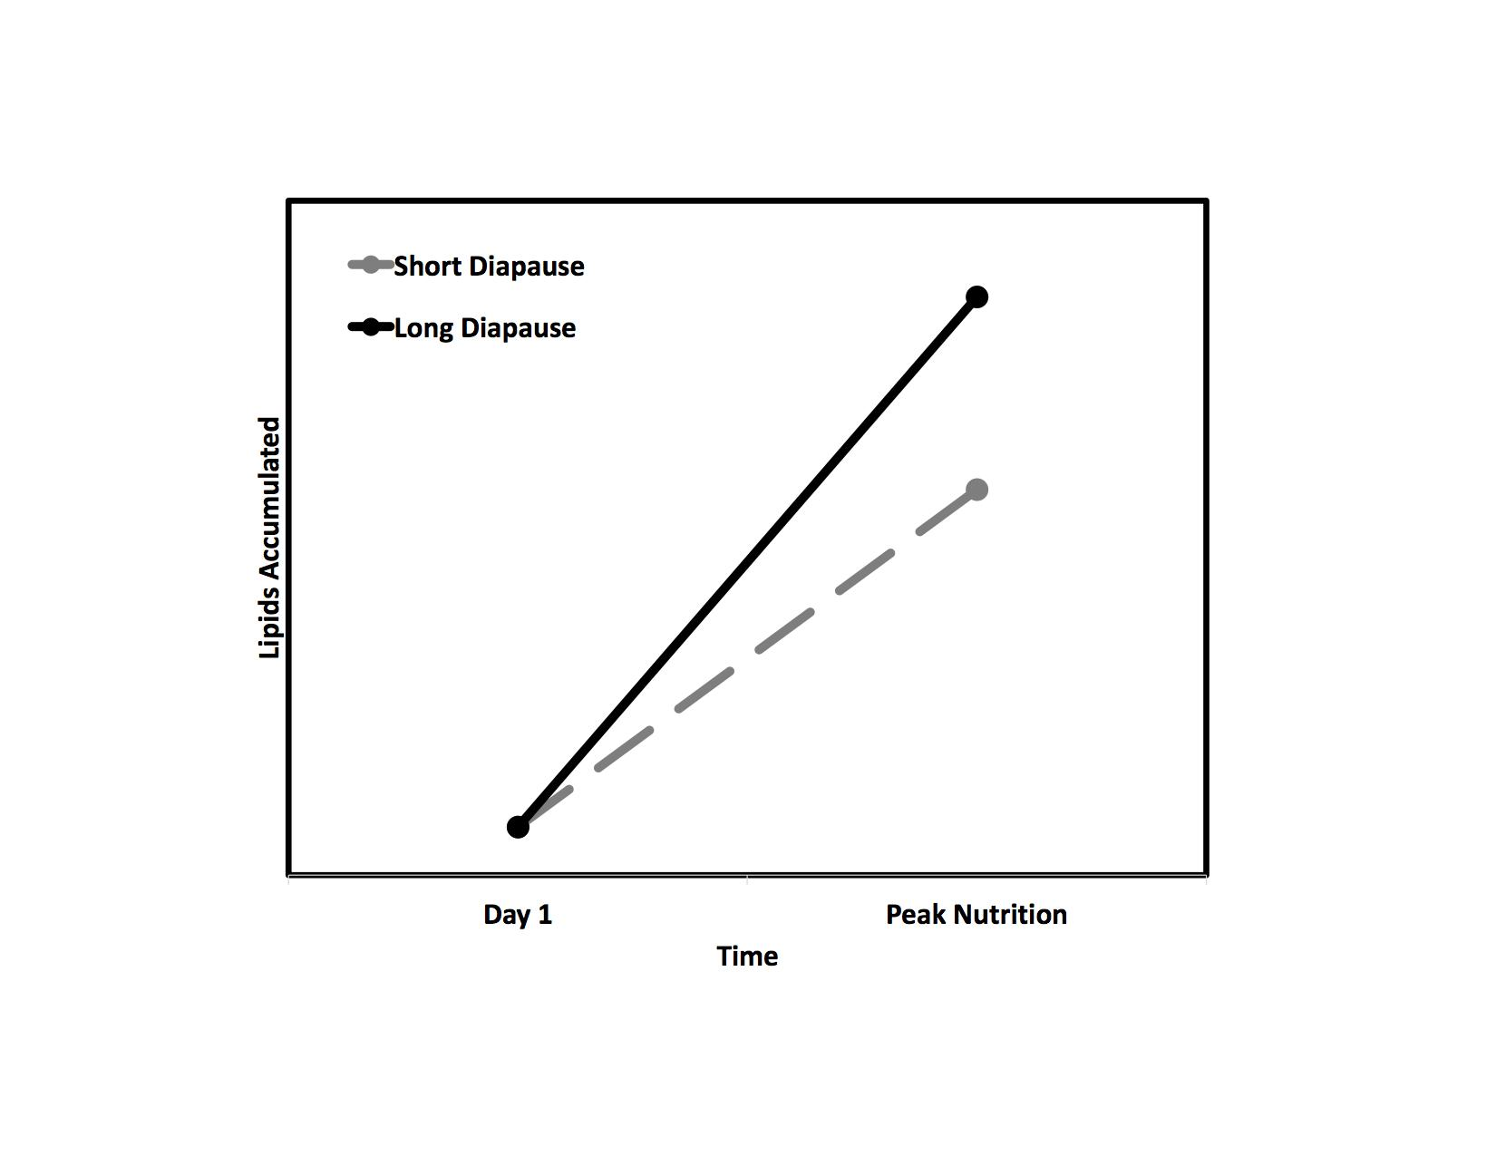

Figure 1-1. Hypothesis based prediction of the relationship between diapause genotype and lipid storage in preparation for diapause

13

CHAPTER 2

THE EUROPEAN CORN BORER, *Ostrinia nubilalis* (LEPIDOPTERA CRAMBIDAE) *Ostrinia nubilalis* (Hub•uner), the European corn borer (ECB), is a phytophagous moth in

the family Crambidae. *O. nubilalis* it occurs in most states east of the Rocky Mountains from Canada to the Gulf of Mexico (Beck and Apple 1961, Capinera 2000, Bohnenblust and Tooker 2010). The host range of the European corn borer is particularly wide and includes grasses, vegetables, and other herbaceous plants with a stem large enough for the larvae to enter (Capinera 2000). Here in the United States, the European corn borer remains the primary insect pest of corn. The cost of controlling this corn pest has been approximated at $1-$2 billion dollars, annually (Hyde et al. 1999). These pests use programmed seasonal dormancy (diapause) to synchronize their life histories with favorable seasons and take advantage of available resources, like corn. At least two diapause genotypes (strains) of European corn borer populations occur in the United States. One strain has a diapause genotype that produces a relatively short diapause length and the other has a diapause genotype that produces a relatively long diapause length. Those insects with the shorter diapause length exit diapause earlier in the spring and the longer diapausing insects exit diapause later in the spring (Showers 1975, Levy 2015).

At the poleward edge of the *O. nubilalis* population range warm spring and summer seasons are short and these pests can complete only one generation per year. As latitude decreases the warm growing season gradually becomes longer. In studying a seasonal cline from north to south, Levy et al. (2015) found polymorphisms in the genes responsible for diapause length are in part responsible for diﬀerences in voltinism observed across latitudes. Each polymorphism plays an important role when diapause is terminated and in uences the number of generations each strain can produce annually. At the poleward boundary of the population range, populations with a short diapause length exit diapause earlier in the spring to take full advantage of the short warm season. After diapause ends, larvae develop into functional adults capable of generating one generation of

14

larvae. At the end of the short growing season the short diapause length genotype has enough time to enter diapause before winter arrives. Further south, the growing season is longer, providing the short diapause length enough time to produce two generations of larvae. The rst generation of larvae mature into adults and produce an additional generation of larvae while the second generation of larvae have enough time to enter diapause before winter begins. The longer growing season is also favorable for the ECB that emerge later in the spring. These larvae with a longer diapause length exit diapause later in spring and produce one generation of larvae able to enter diapause before the start of winter. The sequential emergence of these pests from diapause increases the number of generations produced at each latitude each year contributing to this pest's continued success.

The eﬀects of anthropogenic climate change will lead to longer growing seasons and as poleward regions will become warmer more geography will be thermally favorable to ECB, thus both the geographic range and voltinism at each point in the range may be increased. Research into the relationship between diapause phenology, nutrition management in preparation for diapause, and how these pests could respond to changing climate could provide possible targets for future pest management.

2.1 Phylogeny of *Ostrinia nubilalis*

The appearance of lepidopterans (butter ies and moths) 190 million years ago marks an important moment in insect evolutionary history (Gruyter 1998). This order is primarily plant feeding and the enormous lineage diversi cation following the emergence of this order corresponds to the colonization of angiosperm hosts by larvae (Wahlberg et al. 2013, Regier et al. 2009). Since its divergence, Pyraloidea represent one of the most diverse superfamilies of Lepidoptera. These lepidopterans feed on almost every major plant group and occupy an enormous diversity of ecological habitat. Pyraloidea moths are major pests of crops, invasive plants, forests, ornamentals, and stored foods (Regier 2012, Zhang 1994). The divergence of the superfamily Pyraloidea occurred approximately 100 million years ago during the Cretaceous period (Wahlberg et al. 2013). Broadly, Pyraloidea moths share morphological synapomorphies

15

including scales at the base of their proboscis, similar wing structures, and paired tympanal organs (Regier 2012). Nested within Pyraloidea are families Crambidae with approximately 10,000 described species and Pyralidae with approximately 5,000 described species (Solis

2007). Diﬀerences in tympanal structures, wing venation, and male genetalia diﬀerentiate these two families (Solis 2007). Larvae in the family Crambidae are characterized by the presence of one or two L setae and adults of this family can also be identi ed by the presence of a praecinctorium. Praecinctorium are specialized structures that improve hearing by joining two tympanum membranes together allowing for directional hearing (Regier et al. 2012, Solis 2007). Species in the family Crambidae occupy most every ecological niche, this family is polyphagous, and many species are important agricultural pests.

The genus *Ostrinia* exists within the subfamily Crambidae. This genus includes 20 species recorded worldwide with each species belonging to either group I, II, or III. Groups are determined based on the number of "uncus" lobes associated with the male genitalia (Allison and Card 2016, Frolov et al. 2007). Group I includes a single member, the American species *Ostrinia penitalis* characterized by having an "unarmed" sacculus and a tri d juxta in the malegenitalia (Allison and Card 2016). Species in group II have a simple or bi d uncus. There are ten species in the trilobed uncus group (group III), all of which are morphologically similar with one clear distinction; male mid-tibia length (2-1). The mid-tibiae and associated structures participate in pheromone emission and are used to subdivide the members of group III with "small", "medium", and "massive" mid-tibiae lengths (Allison and Card 2016, Frolov et al. 2007). The distinction of group III species extends to ecological preferences, including two important agricultural pests, *Ostrinia furnacalis*, the Asian corn borer and *Ostrinia nubilalis*, the European corn borer (Frolov et al. 2006, Allison and Card 2016, Kim et al. 1999). Many of the species in the *Ostrinia* genus live sympatrically in space and time and much work has been done to understand how these species have evolved and how they remain reproductively isolated. Special attention has been paid to the chemical blend of the female sex pheromone of each group.

16

Across group III speci c isomers of tetradecyl-acetate (14:OAc) are produced at species-speci c concentrations that drive male attraction to females (Frolov et al. 2006). Diﬀerences in pheromone component concentrations is thought to be a strong driver maintaining isolation between diﬀerent *Ostrinia* species and even diﬀerent genotypes of *O. nubilalis*. Sex pheromone biosynthesis in European corn borer females involves the

-oxidation of palmitic acid into (E)-11-tetradecenoyl and (Z)-11-tetradecenoyl precursors that can be reduced into their corresponding fatty alcohols then acylated into a pheromone molecule (Lassance et al. 2010). The speci c ratio of precursor molecules converted into pheromone diﬀers between two naturally segregating z-chromosome genotypes (Lassance et al. 2010).

The gene responsible for pheromone synthesis has two diﬀerent alleles. Higher concentrations of (Z)-11-tetradecenyl acetate in the Z strain sex pheromone blend is due to the aﬃnity of

(Z)-11-tetradecenoyl precursors to the fatty acid reductase enzyme produced from the pgFAR-Z allele (Lassance et al. 2010). Alternatively, the high concentration of (E)-11-tetradecenyl acetate characteristic of the E strain is due to increased aﬃnity of (E)- 11-tetradecenoyl precursors to the fatty acid reductase produced from the pgFAR-E allele (Lassance et al.

2010).

The onset of diapause in European corn borer is environmentally programmed by photoperiod and temperature but the length of diapause varies between strains. The Pdd region of the Z-chromosome is a major factor associated with diapause length and is partially responsible for determining voltinism during the growing season (Dopman 2005). The univoltine and bivoltine genotypes express longer and shorter diapause phenology respectively, as well as diﬀerences in their pheromone blend. Univoltine Z strain larvae (UZ) enter diapause earlier in the fall and exit diapause later in the spring compared to the bivoltine E strain genotype (BE). Longer diapausing individuals are sexually mature later during the growing season than individuals with a the shorter diapause. Diapause length diﬀerences along with sex pheromone blends maintain isolation between European corn borer strains.

17

2.2 Life History of *Ostrinia nubilalis*

*Ostrinia nubilalis* (European corn borer, ECB) has evolved in the temperate regionswhere it encounters favorable and unfavorable seasonal changes. During spring and summer, long day lengths (photoperiod) and warm temperatures favor continuous growth and development and the life cycle of ECB can be completed in fty days. Beginning in the spring and under field conditions, diapausing larvae exit diapause, develop into pupae, and approximately 12 days later those pupae eclose as adults and eventually begin mating (Capinera 2001). Oviposition in sexually mature adults lasts approximately 14 days with females laying between 20 and 50 eggs each day and 400 to 600 eggs across its lifetime (Capinera 2000). The attened, scale-like eggs are usually deposited on the underside of leaves and hatch four to nine days after being laid. In the field, larvae proceed through six larval instars. Once larval growth is completed larvae enter the wandering stage (Capinera 2000). Wandering is characterized by the termination of feeding and the clearing of the larval gut in preparation for the next developmental step (Gelman and Hayes 1982). As summer ends and fall begins, shorter photoperiods and lower temperatures become unfavorable to the continued growth and development of ECB. In the fall after the wandering stage ends competent larvae recognize the shorter photoperiod, suspend their development and enter a facultative diapause.

Diapause is a state of increased stress tolerance, marked by developmental arrest and suppressed metabolic activity (Tauber and Tauber 1981, Hahn and Denlinger 2007). Photoperiods are latitude speci c and have reliably cycled with seasonal changes. Because of its speci city, many animals in temperate regions rely on photoperiod cues to synchronize their life histories with their local environment to initiate diapause. Ahead of winter and during the nal larval instar ECB become sensitive to photoperiod. When photoperiod reaches a critical threshold it initiates the diapause genotype and programs ECB larvae for diapause. Within *O. nubilalis* at least two diﬀerent diapause genotypes exist with genetically diﬀerent diapause lengths (Showers 1975, Roelofs 1985, Levy 2015). The initiation of diapause leads to

18

major physiological changes and alters the life history trajectory of European corn borer larvae. Diapausing larvae depend on predictable cues to initiate and terminate diapause. Climate change and warmer temperatures could aﬀect the synchrony between European corn borer life history and its environment, and understanding these eﬀects may be crucial to how we manage this pest.

19

Table 2-1. Adapted from Frolov et al. 2007. Mid-tibiae length of male *Ostrinia* species as described by Mutuura & Munroe (1970).

Uncus size Species

Small

*O. nubilalis*

*O. orientalis*

*O. furnacalis*

*O. dorsivittata*

Medium

*O. narynensis*

*O. kurentzovi*

Large

*O. scapulalis*

*O. zaguliaevi*

*O. zealis*

*O. putzufangensis*

20

CHAPTER 3

EUROPEAN CORN BORER: THE RELATIONSHIP BETWEEN STORED RESOURCES AND

DIAPAUSE TIMING

3.1 Introduction

Numerous abiotic factors vary across environments, and speci cally how these factors vary is important for understanding the relationship between the life history timing of animals and resources in those environments. Temperature and daylight hours are two in uential abiotic factors and changes in these two factors aﬀect the availability of nutrition, mates, and habitat of animals across most environments. To be successful, animals must monitor both their internal condition and external environmental factors, then respond to changes in those environments as they occur. Environmental variation that is stressful and occurs over a relatively short period of time can be categorized as acute stress while stressful environmental variation occurring over a relatively prolonged period can be considered chronic stress. For insects, stress could be any condition that, if encountered, impacts growth, reproduction,

or survival. Common environmental stresses for insects include extreme temperatures, ice, desiccation, and reductions in the availability of food. Insects have evolved to be active when environmental conditions are favorable and avoid conditions that become too stressful. Many insects accomplish synchrony between environmental variation and life history timing through dormancy.

Generally, dormancy is an environmentally induced state of altered physiological activity used by insects to mitigate the eﬀects of both shorter-lived acute stress and longer-lasting chronic seasonal stress they encounter in their environment (Kotl 2006). A common acute stress insects experience is daily temperature uctuation. As the sun rises, increasing temperatures provide favorable thermal conditions for insect activity. Many insects use warm daytime temperatures to accomplish tasks like gathering resources or searching for mates. After sunset, temperatures tend to fall, conditions can become unfavorable, and insects must protect themselves. In response to an immediate acute stress, like low daily temperature some insects use a type of short-term dormancy, termed quiescence. Quiescence is a transient state of

21

reduced activity that insects can use to temporarily protect themselves from acute stress (Kotl 2006). Once the stress is relieved (provided the exposure was not too extensive), quiescence is reversed and the insects activity can resume after some period of recovery. Seasonal changes in temperature are a familiar chronic stress that insects experience their environments. Warm temperatures generally persist during the spring and summer and cooler temperatures persist in the fall and winter. During warm seasons insect activity generally increases, and during the cool seasons insect activity generally declines. Fall and winter in temperate regions are uniquely stressful seasons, especially for insects. For insects and other ectotherms, unfavorable low temperatures in fall and winter slow metabolic activity and decrease their rate of development (Nespolo et al. 2003). Many temperate insects protect themselves from unfavorable seasons by inducing a programmed seasonal dormancy, termed diapause. Unlike quiescence, diapause is generally induced well before environmental conditions degrade and become too stressful for an insect.

Diapause is a genetically regulated, environmentally in uenced alternative developmental trajectory that is usually marked by metabolic suppression and arrested development in

a speci c life stage (Kotl 2006). Surviving winter and fall in diapause requires insects to remain dormant for months, exposed to harsh conditions typically without access to nutrition. To maximize survival, the onset of diapause must precede the appearance of unfavorable environmental changes. By monitoring environmentally consistent cues that cycle with seasonality, insects can reliably predict, prepare for, and protect themselves from stressful seasonal changes. This alternative life history trajectory is crucial for maintaining an insects synchrony with its environment. Broadening our understanding of diapause will help us as a eld to predict how insects may respond to intensifying environmental variation, particularly anthropogenic change.

Earth’s climate is warming. According to the National Oceanic and Atmospheric Administration, 2016 was the warmest year on record with global surface temperatures and North American land surface temperatures averaging 0.94*◦*C and 1.86*◦*C above the

22

20th century averages, respectively (NOAA National Centers for Environmental Information 2017). Conservative projections of future temperatures estimate at least a 1.5*◦*C increase in global surface temperature by the end of the 21st century with temperatures continuing to increase thereafter (DeLucia et al. 2008, Stocker et al. 2015). Seasonal temperature averages in the United States during 2016 echoed this upward trend for all four seasons surpassing

all previously recorded temperature averages (NOAA National Centers for Environmental Information 2017). Warmer seasonal temperatures will eﬀectively make summer warmer and shift the onset of summer earlier in the spring and the end of summer conditions will occur later in the fall (Bradshaw and Holzapfel 2006, Hahn and Denlinger 2011, Scriber 2014). Warmer days and longer summers will shrink spring, fall, and winters in temperate regions.

Seasonal temperature increases will alter the distribution of warm temperatures

geographically and increase the duration of warmer temperatures. Across latitudes, warm

and cool seasons vary. Towards the poles, warm seasons are mild and short while cool seasons

are relatively colder and longer. This temperature gradient results in longer lasting unfavorable

environmental conditions towards the poles and shorter, milder winter conditions towards the equator (Parmesan et al. 1999, Breed et al. 2012). As global and seasonal temperatures rise, the duration of unfavorable seasons will decrease at these poleward latitudes and warm favorable seasons will increase. Longer warm seasons at these poleward latitudes will mimic adjacent lower latitudes eﬀectively increasing the geographical range of summer for longer during the year. Increased duration and geography of summer temperatures will be detrimental to some insects and a bene t to others. Those insects best equipped to synchronize their activity with the longer warm seasons while continuing to predict chronic stress and protect themselves from the shorter cool seasons could be successful as climate continues to change.

As climate changes, insects whose populations are impacted negatively by those changes can be colloquially termed losers and those impacted positively can be termed winners. Insect performance is in uenced by the thermal conditions they experience in their environments and increased temperatures could aﬀect animals either positively or negatively (Huey and

23

Stevenson 1979, Chown 2007). Insect growth rates generally correspond to favorable seasonal temperatures with higher temperatures increasing growth and development. Increased growing season temperatures for ectothermic insects could increase their metabolic rates, speed up their growth, and possibly shorten development time to reproductive maturity. Shifts to a later onset of fall and the end of summer temperatures could provide winning insects with more time to develop and reproduce, possibly increasing the number of generations produced each year (Bale et al. 2002, Bradshaw and Holzapfel 2006, Hahn and Denlinger 2011, Scriber 2014). The direct and indirect interactions between temperature and season length for the resulting winners could lead to expanded geographic ranges, increased population size, or increased times of activity (Hughes 2000, Williams et al. 2008).

Insects that are unable to shift the geographic range of their populations poleward or unable to tolerate increasing temperatures in their current environment could be climate change losers. As annual temperatures rise, the warmer regions of losing insect's geographical ranges could overheat. Regions that are too warm will be rendered unfavorable to certain insects, their southern distributions will compress, and their populations will shrink. Winners that are able to tolerate warmer temperatures could experience a net increase in both population size and geographical range with more individuals spread across more geography. For winners, warmer temperatures could lead to poleward shifts of entire geographical ranges to track favorable environments. Additionally, some insects could experience no change in the distribution of their range with respect to the equator but an increase in their poleward range distribution. A poleward shift of an insect's entire geographical range could mean no change in population size, while the combination of an increasing poleward distribution and stable equatorial distribution could lead to population increases. For example, changes in range have been observed in 35 species of non-migratory European butter y species. Of these butter ies, 63% were observed to have a distribution shift northward and 3% were observed to have a distribution shift southward (Parmesan et al. 1999). As favorable thermal conditions for winning insects shift farther poleward and warmer days increase in frequency and duration, the

24

spatial distribution of winning insects could track favorable conditions to take advantage of the increased distribution of warmer regions.

Environmental temperatures directly aﬀect an insect’s body temperature and performance. The eﬀect of body temperature on performance can be described using a thermal performance curve (Huey and Stevenson 1979). At the peak of this curve is an insect’s thermal optimum, this is the temperature where performance is maximized. The range of temperatures where the performance of an insect is half of the thermal optimum represents the thermal breadth. Finally, the range of temperatures within which any performance is permitted is an insects thermal tolerance range. Temperatures at the edge of an insect’s thermal tolerance are termed the critical thermal maximum and critical thermal minimum, respectively (Bale et

al. 2002, Huey et al. 2012, Sinclair et al. 2016). Warmer temperatures for climate change losers could directly reduce their performance by exceeding their thermal breadth. Continued temperature increases for these losing insects could exceed their thermal maximum and eventually cause mortality. Winners in contrast could have wider thermal breadths and tolerate warmer temperatures. Winners, whose thermal environment is currently below their thermal optimum, could experience increased performance as temperatures increase towards their thermal optimum.

In a review of the eﬀects of thermal conditions on population fitness (with fitness defined as the intrinsic population growth of r-strategy insects), Deutsch et al. (2008) tracked and compared population size between 38 representative insect species from temperate and tropical latitudes. For those representative species across temperate latitudes, the thermal breadth of these insects tended to be wider and the thermal conditions experienced in these locations, on average, tended to be further away from their critical thermal maximum compared to the representative taxa from tropical latitudes (Deutsch et al. 2008). In the tropics, environmental temperatures vary little relative to temperatures in temperate regions and insects in tropical regions experience temperatures that tend to be closer to their optimum temperature relative to temperate insects whose environment tends to be cooler than optimum. This suggests that

25

tropical insects already live near their thermal limits and thus could quickly become losers as climate warms.

As average seasonal temperatures increase, the duration of the warm growing season is also expected to increase. However, seasonal cues insects use to predict changes in their environment, like photoperiod, will not change. Photoperiod, like temperature, is an important environmental cue used by insects to predict changes in their environment. Photoperiod,

or the duration of daylight during a twenty-four hour day, reliably cycles with seasonal change annually. Photoperiod consistently changes incrementally at increasing latitudes away from the equator (Hut et al. 2013). During the summer, photoperiod is longer and also increases as latitude increases; while during the winter, photoperiod is shorter and decreases as latitude increases. Insects in temperate regions use these consistent, incremental changes in photoperiod at speci c latitudes to synchronize their life histories with the seasonal changes in their environment.

In time, the predictions of unchanging environmental cues, like photoperiod, will become decoupled from actual seasonal changes as growing seasons become longer and winter shrinks. A cue that previously signaled the end of the growing season will underestimate the end of the longer growing season. Hypothetically, a photoperiod of thirteen hours that previously indicated the average beginning of the growing season could, as temperatures increase, indicate on average the second week of the growing season. Warmer seasonal temperatures will uncouple historical photoperiods from seasonal changes in temperature and resource availability. Those insects that experience range shifts will be exposed to environmental cues, like photoperiod, that are intrinsic to these northern latitudes. Winners could be pre-adjusted, or they could adjust the timing of their seasonal life histories to these shifted cues in the environments as they expand their ranges through phenotypic plasticity or evolutionary adaptation. Phenotypic plasticity is de ned as the capacity of a single genotype to express multiple diﬀerent phenotypes as a function of the environmental conditions that the genotype encounters (Agrawal 2001). Evolutionary adaptations are genetic changes that occur within

26

populations due to selection (Lee 2002). Failure to adjust to photoperiods indicating warmer northern latitudes could negatively impact the timing of life history events for those populations that had expanded their ranges northward, turning winners into losers.

The pitcher plant mosquito (*Wyeomyia smithii*) provides one example of how insects could adjust to longer and warmer growing seasons through evolutionary adaptation. As larvae, pitcher plant mosquitoes grow and develop in the in the water- lled leaves of pitcher plants. The geographic range of this temperate mosquito extends as far south as the Gulf of Mexico and as far north as northern Canada. Across this wide latitudinal range, pitcher plant mosquitoes experience their longest growing seasons at the southern end of their range and increasingly shorter growing seasons at more northern latitudes. At the end of the warm growing season within a particular local, photoperiod gets shorter. Larvae perceive when photoperiod drops below a genetically determined number of light hours and then enter the larval diapause developmental trajectory.

Bradshaw and Holzapfel (2001) sampled multiple populations of *W. smithii* larvae from latitudes between Florida and Canada in the years 1972, 1988, 1993, and 1996 and reared them in a common-garden laboratory setting under strict environmental control. Populations collected in 1972 and 1996 were exposed to a range of diﬀerent photoperiods to determine their critical photoperiod (Bradshaw and Holzapfel 2001). Critical photoperiod is the number of light hours required to induce diapause in 50% of a population. In *W. smithii* the critical photoperiod for diapause induction is highly heritable. In 1972, the critical photoperiod of larvae populations collected at 50*◦*N, averaged 15.79 hours while the critical photoperiod

of larvae populations collected in 1996 at the same latitude averaged 15.19 hours, a point later in the fall. Bradshaw and Holzapfel (2001) showed that populations of the pitcher plant mosquito, *W. smithii*, have shifted their critical photoperiods for diapause induction to extend their growing season, consistent with predictions for climate change.

Because of the rigor with which these experiments were conducted and the highly heritable nature of critical photoperiod within this species, these results suggest the populations

27

collected in 1996 have evolved and are now genetically diﬀerent than populations collected in 1972. Northern pitcher plant mosquitoes, on average, are delaying diapause by approximately 9 days and this shift correlates with the average increase in the number of warmer days experienced in this region (Bale and Hayward 2010). Delayed diapause initiation could be evolutionarily adaptive. For pitcher plant mosquitoes, warmer temperatures are indirectly responsible for the increased availability of environmental resources these mosquitoes need to grow and develop. The mosquitoes that delay diapause initiation could access those resources and continue to grow, develop, and reproduce for an additional 9 days. For some insects, warmer seasonal temperatures and longer growing seasons will increase the duration of resource availability. Insects that can adjust to longer growing seasons without compromising the protection diapause aﬀords them could be winners as climates change.

Diapause is a genetically determined alternative life history trajectory that is cued by token environmental stimuli and leads to substantial physiological changes. For most temperate insects, maintaining a suitable metabolic rate for continued development becomes challenging when temperatures fall too low. Further, as resource availability declines, they struggle to acquire enough energy to fuel metabolism, growth, and development. Consequently, low metabolic activity reduces growth and can eventually cause mortality. Insects in temperate regions generally predict the seasonal change using photoperiod alone or in concert with other environmental cues, like temperature or host-plant quality, to induce diapause and avoid the stress of prolonged seasonal stress in their environments.

Within a single insect species, the environmental cues that stimulate diapause, the life stages sensitive to those cues, and the resulting diapause phenotype are typically consistent (Bale and Hayward 2010). The traits that mark diapause are largely genetically determined and highly heritable. The developmental stage when diapause occurs can vary from species to species and, in rare cases, can even vary among populations within a species, but each species typically diapause in one characteristic life-stage. Variation in diapause life stage aside, the diapause developmental trajectory always has three sequential stages: pre-diapause, diapause,

28

and post-diapause. Before diapause can be induced, an individual must reach a genetically determined sensitive period. Sensitive insects can perceive the environmental cue or cues that induce diapause, and during this period they are physiologically competent to respond to that cue or cues. During pre-diapause, the sensitive stage perceives the necessary environmental cue or cues and there is a shift away from continuous development and towards the diapause developmental trajectory, a time called the diapause-preparatory period.

While in diapause, insects must continue to meet their metabolic energy requirements. However, most insects do not feed during diapause. The preemptive induction of diapause before the onset of unfavorable conditions provides insects the opportunity to accumulate and store resources needed to survive diapause before seasons change (Kotl 2006). During the diapause preparatory period, many insects accumulate and store nutrients in the form of lipids, proteins, and carbohydrates. Because most insects do not feed during diapause it is imperative that insects accumulate enough resources to meet the energetic demands of the long diapause period. In addition to surviving diapause, after diapause ends insects must have enough energy remaining to meet the anabolic requirements for development, metamorphosis, repair, and post-diapause activities like reproduction (Hahn and Denlinger 2007, Sinclair 2015).

Nutrition management prior to the onset of diapause and during diapause is essential to surviving winter and becoming a functional adult. Entering diapause without accumulating enough energy stores to sustain metabolic activity could lead an insect to premature termination of diapause during winter or death while in diapause due to a lack of metabolic resources. Insects with suboptimal energy stores that successfully complete diapause may be unable to complete post-diapause development, or they could mature into adults with reduced functionality. Metabolic activity in many insects is directly associated with environmental temperatures and increased temperatures could expose animals to energy stress as they prepare for diapause and during diapause (Williams et al. 2015, Sinclair 2014). Warmer winter temperatures could increase metabolic activity increasing the rate nutrients stores are depleted during diapause. Managing nutrition storage could be a strategy insects use to mitigate the

29

eﬀects of increased temperatures and adjust to climate change. Understanding how nutrition storage response of insects preparing for diapause and during diapause could inform and innovate pest management strategies uncover ways to manage important pests as climate changes and seasons become less predictable.

The goal of this research was to determine the eﬀect of diapause genotype on nutrition stores in preparation for diapause, speci cally how diapause initiation programming alters lipid accumulation in preparation for diapause, and subsequently lipid depletion during diapause between two diapause genotypes. To test the relationship between diapause initiation, diapause genotype, and lipid accumulation I used two strains of *Ostrinia nubilalis* (European corn borer) with diapause genotypes that diﬀer in the length of the diapause period, one with a long diapause and the other with a shorter diapause. European corn borer is suitable as a study system because it is easy to rear in the laboratory and the diapause phenotype can be induced in each strain using photoperiod. I also tested the eﬀect of diapause genotype on lipid accumulation by comparing European corn borer larvae of each genotype reared in conditions that permit continuous development to those reared in conditions that induce diapause. I predicted that lipid accumulation in preparation for diapause would be associated with the length of time each strain spends in diapause. Speci cally, the amount of lipids stored in preparation for diapause would be dependent on the genotype that determines diapause length. European corn borers with a shorter diapause length would require less energy to complete diapause and in turn will store less lipids in preparation for diapause than larvae with longer diapause.

3.2 Methods

3.2.1 General Rearing

*Ostrinia nubilalis* eggs were provided as a courtesy from Dr. Erik Dopman's laboratoryat Tufts University. Two genetically distinct strains of larvae used during my experiment were collected as a mixture of larvae, pupae, and adults from New York state prior to 2015 and kept as separate colonies (Wadsworth et al. 2015). Strain identity was determined genotypically

30

using the pgFAR autosomal gene, this gene codes for an important enzyme involved in determining the female sex-pheromone blend, and is partly responsible for strain diﬀerences (Lassance et al. 2010). Female larvae of each genotype produce diﬀerent pheromone blends based on the enzyme allele they carry. Univoltine-Z (UZ) larvae have the *pgFAR-Z* allele and the *pgFAR-E* allele is carried by Bivoltine-E (BE) larvae (Lassance et al. 2010). For the duration of the experiment, colonies of each genotype were mass reared at 26*◦*C under a 16L:8D photoperiod to promote continuous development.

Individuals intended for experimentation were collected as eggs from each colony and

organized in to "biological cohorts". A biological cohort was de ned as clutches of eggs

oviposited on a single day by females of the same strain. Before sampling, all eggs were rst

held under a 16L:8D photoperiod and at the standard temperature and humidity (23*◦*C and

65% rH) until they hatched. Upon hatching each biological cohort was divided and reared in

either a "diapause" treatment to program diapause (12L:12D photoperiod, 23*◦*C, and 65%

rH) or a "non diapause" treatment to permit continuous development (16L:8D photoperiod,

23*◦*C, and 65% rH). Larvae from each biological cohort were reared in mass and provided

arti cial ECB diet ad libitum, purchased from Frontier Agricultural Sciences (Product F9478B).

As biological cohorts within each treatment reached the end of the fourth instar, larvae were

separated and reared individually in 32-well bioassay trays purchased from Frontier Agricultural

Sciences (Product RT32W). Each well of the bioassay tray was provisioned with diet and

returned to its original treatment conditions until sampling.

3.2.2 Experiment 1: Estimating the Onset Diapause and Classifying Diapause Programmed Larvae Using Metabolic Activity

Comparing stored nutrition between each genotype was contingent on sampling larvae at developmentally similar time points and required characterization of the diapause ontogeny of each diapause genotype. Diapause programming in most insects suppresses metabolic activity, development, and while in this state feeding is also interrupted. European corn borers diapause as larvae at the end of the last larval instar feeding stage, a so-called wandering larval diapause.

31

After diapause ends, larvae resume normal development; rst pupating and then eclosing as adults. I tracked the developmental trajectories of individuals exposed to diapause-inducing and non-diapause treatments for forty days starting on day one of the last larval instar. Each day, larvae were observed and I recorded the developmental phenotype of each individual and its "diapause" status. Within each genotype, diapause was determined by comparing development of individuals reared in each treatment as outlined below.

Larvae exposed to the non-diapause treatment eventually pupated. The timing of pupation in the non-diapause treatment was used as a developmental time point to mark the end of the larval stage. Diapause programmed individuals that remained larvae after the time that all the non-diapause individuals pupated were assumed to be in diapause. Diapause programmed larvae that pupated after diapause onset but before the end of the 40-day trial were classi ed as "shallow diapause" individuals, and diapause-programmed larvae that did not pupate during the 40-day trial were recorded as "deep diapause" larvae. On day forty, deep diapause was recorded for 100% of the diapause programmed individuals with the long diapause genotype (3-1), whereas only 33.3% of individuals from the short diapause genotype were recorded as deep diapause larvae (3-1). The remaining 66.6% of diapause-programmed larvae from the short-diapause genotype were characterized as being in shallow diapause because they pupated before 40 days.

Ultimately, the short-diapause genotype was much more likely to terminate diapause early, even under short-day cues, than the long-diapause genotype. An outstanding question is if these shallow-diapausing short-genotype individuals would store less fat than deeper-diapausing individuals within the short-diapausing strain. I initially wished to determine whether I could identify whether a short-diapause genotype larvae would be in shallow or deep diapause by measuring it's respiratory rate at the onset of larval diapause. Hypothetically, metabolic activity is suppressed in preparation for diapause and activity is restored in individuals terminating diapause to support development and metamorphosis. If metabolic activity is increasing ahead of pupation in shallow diapause individuals, it could be possible to separate shallow

32

diapause larvae from deep diapause larvae by assaying for metabolic activity wherein I expected shallow-diapausing individuals to have higher metabolic rates than deep-diapausing individuals.

A primary byproduct of metabolic activity is the production of carbon dioxide (CO2). In general, increases in metabolic activity are directly correlated with increased CO2. Quantifying CO2 production as a proxy for metabolic activity could be useful in determining the onset of diapause and separating shallow from deep diapause individuals. I measured CO2 production of larvae programmed for diapause to determine the degree to which metabolic activity diﬀered between each diapause genotype and diﬀered between shallow and deep diapausing individuals. Beginning on day one of the last larval instar, for each larvae I measured mass gravimetrically and recorded CO2 production every day. Before measuring CO2 production, larvae were isolated into air tight chambers free of CO2. Each chamber was designed from plastic Air-Tite 5mL Norm-Ject luer tip syringes (product A5) tted with a three position stopcock. To produce CO2 free air when sealing the insect into the respiration chamber, atmospheric air was pumped and bubbled through water with a pH of 4. The CO2 free air was then pumped into the chamber to replace atmospheric air initially sealed in the chamber with the larva that may have contained some environmental CO2. Larvae were then held in these chambers for approximately one hour. After the hold time elapsed, each sealed chamber was attached to a Licor gas analyzer (model LI6262) to quantify the CO2 produced by each larva. These data were visualized using Expedata software.

The day mass peaked in individuals with the short diapause genotype was used to compare CO2 production between shallow diapause larvae and deep diapause larvae at an equivalent developmental time point (3-7A). After measuring and comparing CO2 production, there was no signi cant diﬀerence between shallow diapause and deep diapause larvae and I was unable to discriminate or remove shallow diapause larvae from deep diapause larvae within the short diapause genotype (3-7B).

33

3.2.3 Experiment 2: A Wandering Assay to Mark Diapause Initiation Timing and Estimate Stored Lipids

Access to nutrition is limited during winter and many diapausing insects do not feed during diapause. Instead, nutrition is consumed during the warm growing season and stored in the form of macromolecules like lipids, proteins, and carbohydrates. Storing nutrition oﬀers diapausing insects energy security and eliminates their need to spend energy on mechanical digestion during diapause. Many insects complete feeding and digestion well in advance of winter and before the onset of diapause. The period after feeding is terminated and before diapause begins is when nutrient stores are at their peak. A sampling regimen that selects larvae during this period after feeding ends but before diapause begins would be a useful developmental time point to compare nutrition storage across cohorts and between diapause genotypes that are programmed for non-diapause or diapause development.

Diapause in European corn borer begins at the end of the ultimate larval instar during a "wandering" period. The wandering stage is common to lepidopterans and is described as a developmental step between larval development and pupal metamorphosis when the gut content is purged and feeding is terminated (Sakurai et al. 1998). As feeding is terminated during the wandering stage larval frass stops being produced. To determine the onset of the wandering stage and approximate peak nutrition stores, I assayed larvae during the nal larval instar for wandering by isolating larvae from diet and tracking their frass production. Larvae were removed from arti cial diet and held in isolation for thirty minutes (3-2). After thirty minutes of isolation, larvae that did not produce frass were recorded as "wandering". Using this wandering assay, I tracked larvae daily and recorded the following developmental events: 1) the day that larvae eclosed into the nal instar, 2) the wandering day - as de ned as the day they stopped producing frass, and 3) pupation.

Wandering day was used to mark the end of larval development across treatments and to approximate the onset of diapause among larvae programmed for diapause. For diapause-programmed larvae, the majority of larvae with a long diapause genotype and larvae

34

with a short diapause genotype reached the wandering stage by day 10 in the last instar

(3-3B). In the non-diapause treatment, the majority of the long diapause genotype larvae and the majority of the short diapause genotype larvae reached the wandering stage by day 6 (3-3A). Hereafter, I sampled larvae for lean mass and lipid content on the day of wandering.

Before the onset of diapause nutrient stores reach their peak during the wandering stage and as diapause proceeds nutrient stores are used as metabolic fuel and depleted over the course of diapause. To investigate the relationship between genetically determined nutrition and diapause length, nutrient stores in diapause programmed larvae were measured before the onset of diapause and during diapause. Diapause programmed larvae were sampled on the rst day of the nal larval instar and on the wandering day of the nal larval instar to capture the peak of lipid storage before the onset of diapause. To capture the rate of nutrition decline during diapause, diapause programmed larvae were sampled at 15, 20, and 30 days after the wandering stage.

At each sampling time point, each larva was assigned a unique identi er and freeze-dried under vacuum to remove water. Samples were determined to be suﬃciently dry when their weight varied by less than 1% over a 24-hour period, and their dry mass was recorded. Dry larval samples were then assigned to an experimental cohort and stored in a -80*◦*C freezer. Each experimental cohort consisted of larvae from each biological cohort. Individuals from each experimental cohort were then measured for lipid mass. To measure lipid mass, lipid content from each larva was extracted using a slightly modi ed Folch method (Gossert et al. 2011). Larvae samples were solubilized in a 3:1 solvent mixture of hexanes and methanol and lipids were removed and collected. The density diﬀerences between hexanes and methanol facilitates physical separation between the two solvents and produces two liquid layers when mixed together. The polarity diﬀerences between the two solvents facilitates the selective solubility of molecules into each layer. Proteins and other charged molecules have polarities similar to methanol and readily solubilize into the denser methanol layer while lipids and other neutral molecules that have polarities similar to hexanes readily soluabilize into the less dense hexanes

35

layer. The less polar hexanes layer containing the neutral lipids was siphoned away from the methanol layer. Finally, the hexanes layer was dried away, concentrating the lipids and allowing for them to be quanti ed gravimetrically.

3.2.4 Statistical Analyses

All statistical analyses were performed using R studio software (R studio Team 2015). In experiment 1 diapause status was measured in 100 larvae for 40 days. The percentage of individuals in diapause was calculated daily by the number of individuals that pupated to the total number of individuals alive during each observation day (larvae and pupa). Wet mass measurements and CO2 production were taken in 100 individuals and analyzed using a linear model. Wet mass, CO2 production, and day of peak mass, were included as xed factors (3-1).

In experiment 2, I calculated the day of wandering as the total number of days between eclosion into the nal larval instar and the day frass production ended. The day that frass production ended for the majority of larvae was determined to be the wandering day. Lipid stores were measured in 266 individuals and analyzed using a linear mixed eﬀects model. The statistical model included: lipid mass, diapause genotype, and treatment as xed eﬀects, diapause genotype and treatment were interacting xed eﬀects, and lean mass was a covariate. Biological cohort was also included in the linear model as nested within experimental cohort, and experimental cohort was as a random factor (3-4)(3-8). Lean mass was measured in 338 individuals and analyzed using a linear mixed eﬀects model. The statistical model included: lean mass, diapause genotype, and treatment as xed eﬀects, diapause genotype and treatment were interacting xed eﬀects. Biological cohort was also included in the linear model as nested within experimental cohort, and experimental cohort was as a random factor (3-2)(3-6).

3.3 Results

3.3.1 Experiment 1: Metabolic Activity

Larvae of the long-diapause genotype responded to diapause programming as expected with deep diapause reported in 100% of individuals (3-1). Individuals in diapause programming conditions were considered in deep diapause if they remained in the larval stage throughout the

36

30-day trial. Diapause programming in the short-diapause genotype larvae was less consistent with 66.6% of larvae showing a shallow diapause phenotype. Individuals that metamorphosed into pupae before the end of the trial were labeled as being in shallow diapause. Despite being reared in conditions that induce diapause, only 33% of short diapause larvae remained in deep diapause by the end of the 30-day trial period (3-1). As individuals reach the end

of the larval stage, nutrition accumulation strategies could diﬀer between larvae preparing for shallow diapause and larvae preparing for deep diapause, so it would be useful to be able to separate shallow from deep-diapausing individuals with in the short-diapause strain on the day of wandering. The peak of wet mass was tracked in individuals from each diapause genotype and used to determine if there was a detectable diﬀerence in peak wet mass between non-diapause larvae, deep-diapause larvae, and shallow-diapause larvae. Additionally, the day of peak wet mass accumulation was used as a developmental time point to compare CO2 production between each group with the expectation that metabolic rates may be useful in discriminating among the shallow vs. deep diapause genotypes.

In the non-diapause treatment, long-diapause genotype individuals peaked in mass on day 5 and short-diapause genotype larvae peaked in mass on day 3 (3-4A). In diapause-programming conditions, mass peaked in long-diapause genotype larvae on day 9 and short-diapause genotype larvae peaked in mass on day 6 (3-4B).

To capture the relationship between photoperiod and metabolic activity I compared CO2 production of diapause programmed individuals to non-diapause individuals of the same diapause genotype (3-6). I found diapause-programmed individuals produce signi cantly less CO2 compared to their non-diapause counterparts (long-diapause genotype: t-value=4.4747, Df=30, p-value=4.77e-05; short-diapause genotype: t-value=4.991, Df=43, p-value=1.04e-05)

(3-1C ,3-1D). Additionally, I compared CO2 production between long-diapause and short-diapause individuals reared in the same conditions (3-5). I found that long-diapause individuals had lower CO2 production than short-diapause larvae, regardless of rearing conditions (diapause programming: t-value=-5.505, Df=26, p-value=8.9e-06; non diapause: t-value=-3.74, Df=47,

37

p-value=5e-04) (3-1A,B). CO2 production was also compared between shallow-diapause larvae and deep-diapause larvae with the short-diapause genotype (3-7B). I found no signi cant diﬀerence in CO2 production between shallow-diapause individuals and deep-diapause individuals (t-value=-1.033, Df=14, p-value=0.3189) (3-1E). Thus, I was unable to use respiratory rate or peak mass to separate shallow from deep-diapausing larvae within the short-diapause strain.

3.3.2 Experiment 2: Stored Lipids

I estimated the peak of nutrient accumulation as occurring at the start of the wandering stage just after larvae terminated feeding. The wandering day was calculated as the number of days needed to reach the wandering stage after eclosion into the nal larval instar. In non-diapause conditions wandering began on day 6 (3-3A) and on day 10 in diapause-programming conditions (3-3B) regardless of diapause genotype.

On the rst day of the last larval instar, diapause-programmed larvae had accumulated more lipid stores compared to their non-diapausing counterparts (t-value=-2.726, Df=75.94, 0.00796) (3-5A). However, there was no diﬀerence in fat stores between the two genotypes when reared within diapause-programming conditions nor did fat stores diﬀer between genotypes in non-diapause conditions on the rst day of the last larval instar. Lean mass

on the rst day of the nal larval instar was not diﬀerent between the two genotypes regardless of rearing conditions (t-value=2.034, Df=5.93, p-value=0.0888l) (3-3A). Similarities in lean mass and lipid mass accumulation at the start of the nal larval instar suggest that the two contrasting diapause genotypes exposed to the same conditions begin that nal larval instar with the same amount of stored nutrition.

Once larvae reached the wandering stage, increases in lean mass accumulation and lipid stores were both clearly associated with diapause programming and diapause genotype. Larvae in diapause programming conditions accumulated more lean mass and stored more fat than their counterparts in non-diapause conditions (lean mass: t-value=-9.685, Df=133.31, p-value=<2e-16; lipid mass: t-value=-10.23, Df=191.6, p-value=6.67e-05) (3-3B) (3-5B).

38

Additionally, long-diapause individuals in diapause programming and non-diapause conditions had greater lean mass and bigger fat stores compared to short-diapause genotype individuals (lean mass: t-value=6.845, Df=10.87, p-value=2.95e-05; lipid mass: t-value=4.08, DF=186.8, p-value=<2e-16) (3-8) (3-3B) (3-5B).

To assess whether the long-diapause and short-diapause genotypes diﬀered in their

utilization of their nutrient stores during diapause, fat stores and lean mass were also measured

in diapause-programmed larvae 15, 20, and 30 days after the onset of diapause

(3-9). Long-diapause individuals had signi cantly more lean mass at the onset of diapause than

short-diapause larvae (t-value=2.450, Df=10.737, p-value=0.0328) (3-7A). Long-diapause

genotype individuals also had larger fat stores at the onset of diapause than short-diapause

larvae (t-value=4.735, Df=16.655, p-value=0.000202) (3-9A). However, within each diapause

genotype lean mass and fat stores did not signi cantly decline during diapause (3-7B, C)

(3-9B, C), with one notable exception. Fat stores among short-diapause individuals was

signi cantly lower on day 15 compared to other days sampled during diapause from the

short-diapause population (t-value=-3.877, Df=111.4, p-value=0.000179) (3-9C). While the

data collected during diapause for lean mass and lipid mass depletion are sparse, they do point

towards the possibility that the rate of lean mass depletion and fat store depletion may not be

associated with diapause genotype.

3.4 Discussion

3.4.1 The Relationship Between Diapause Genotype and Nutrient Storage

The induction of diapause before the onset of unfavorable seasonal change is one strategy used by insects to synchronize their life history with seasonality. Diapause is genetically determined and leads to suppressed metabolic activity, suppressed development, and many insects do not feed during diapause (Kostal 2006). The time diapausing insects spend avoiding winter increases the duration of their life cycle and requires additional energy to fuel their metabolism. After diapause ends, insects must have enough energy to resume continuous development and become functional adults. Neglecting to accumulate enough nutrition prior

39

to the onset of diapause could restrict entry into diapause and for those insects that do enter diapause, reduced nutrient stores could inhibit their ability to complete diapause. Further, mismanagement of nutrition during diapause can lead to reduced adult function and lower fecundity after diapause ends.

Sub-optimal nutrition storage has been previously implicated in restricting entry into diapause and reducing the amount of time spent in diapause in a study that explored this very relationship using *Calliphora vicina* as a model. Diapause in the *C. vicina* y oﬀspring begins maternally where adult female flies exposed to short photoperiod days alter how they provision the eggs of the oﬀspring they lay, programming her oﬀspring for diapause. After diapause programmed larvae hatch they begin feeding and storing nutrition in preparation for a larval diapause. Based on the research of Saunders (1997), diapause in these y maggots appears to be regulated by photoperiod, temperature, and nutrition. Speci cally, restricting the amount of nutrition among diapause programmed larvae had a signi cant eﬀect on entry into diapause and the amount of time larvae spent in diapause before pupating. For larvae whose access to nutrition was restricted 5-days after hatching, 40.5% continued development and pupated, avoiding diapause compared to larvae whose access to nutrition was restricted 8-days after hatching, allowing them to get bigger and fatter, at which point 95% of larvae entered diapause (Saunders 1997). Additionally, Saunders (1997) also compared the time spent in diapause between small larvae weighing less than 40mg and large larvae weighing over 60mg. Small larvae were associated with a shorter diapause and pupated approximately 20-days after hatching, however large larvae were associated with a longer diapause and pupated approximately 50-days after hatching (Saunders 1997). These results suggest an important link between diapause preparation, nutrition storage, diapause entry, and diapause survival.

According to my research, *O. nubilalis* larvae increase nutrient storage, speci cally lipid stores prior to the onset of diapause. Additionally, there is a clear association between diapause genotype and nutrition storage with the long-diapause genotype storing more nutrition than short-diapause larvae before the onset of diapause. My results show

40

an indirect correlation between diapause length and nutrition storage in which expressing a longer diapause for larvae is associated with larger nutrition stores, possibly because these greater stores are needed to support metabolic activity during a longer, more energetically demanding diapause period.

European corn borer is a primary pest of maize in the United States that uses diapause to synchronize its life history with favorable seasons. There are many studies of note that have addressed the relationship between diapause and nutrition storage and those studies have uncovered several physiological strategies used by insects to manage nutrition in preparation for diapause and during diapause. Some insects increase protein storage prior to diapause as is the case for Colorado potato beetles (*L. decemlineata*) (Kort and Koopmanschap 1994) and southwestern corn borers (*D. grandiosella*) (Brown and Chippendale 1978), while others such as the pink bollworm (*P. gossypiella*) (Adkisson et al. 1963) and

*C. pipens* mosquitoes (Mitchell and Briegel 1989) demonstrate signi cant increases in lipidaccumulation before diapause begins. In addition to nutrition management, surviving diapause could be accomplished by adjusting the response of the diapause trait to the environmental cues like photoperiod that program diapause.

As climate change progresses, the length of the favorable season will grow longer and temperatures during both favorable and unfavorable seasons will continue to increase. However photoperiod at speci c locale will not be altered by climate change. Warmer temperatures during the spring and summer could increase the rate of development for these pests and lead to an increase in population size, number of annual generations, or both (Pollard et al. 1995, Bale 2008). Because climate change is also increasing fall and winter temperatures, insects could be at a disadvantage as they prepare for diapause and enter diapause at these warming temperatures. Increasing temperatures during diapause preparations and during diapause

will increase metabolic activity and require more energy to be expended to support elevated metabolic activity. Some insects have overcome metabolic costs associated with developing

41

under warmer temperatures by adjusting their response to the environmental cues that program diapause.

In this study, larvae with the long-diapause genotype responded to diapause programming with what I characterized as deep diapause while the short-diapause genotype responded to the same diapause programming with a deep diapause phenotype and a shallow diapause phenotype. Larvae in deep diapause remained in larval diapause for the duration of these experiments and larvae in shallow diapause terminated diapause early and pupated. The variation in the response of short-diapause genotype larvae to diapause programming suggests that photoperiod alone may not be suﬃcient to maintain diapause in this among short-diapause genotype individuals compared to the long-diapause strain larvae reared under identical conditions (Beck 1960). Variation in the depth of diapause could be one way European corn borers adapt to climate change. Longer growing seasons for European corn borers introduces the possibility of having access to favorable conditions that last longer. However, gaining access to longer growing seasons could require these pests to cope with preparing for diapause and diapausing in warmer environments, or corn borers may adjust their response to photoperiod and delay diapause induction.

Many diapausing insects manage the energetic demands of their metabolism during diapause by storing nutrients in the form of proteins, carbohydrates, or lipids. Like for many other animals, lipids are a commonly used macromolecule stored by insects before the onset of diapause and lipids are used during diapause to fuel their metabolism (Arrese and Soulages 2010, Hahn and Denlinger 2011). In this study, lipid stores were measured to approximate nutrition stores between diapause programmed European corn borers with diﬀerent diapause genotypes expressing diﬀerent diapause lengths. These results suggest an indirect correlation between diapause length and nutrition accumulation where individuals programmed for diapause with a relatively longer diapause length stored more nutrition compared to their shorter diapause length counterparts. I also tested for depletion of fat stores during diapause. The response of short-diapause genotype individuals to diapause programming included about

42

1/3 of individuals showing a deep-diapause phenotype consistent with that observed in the long-diapause genotype and 2/3 individuals showing a shallow-diapause phenotype. I de ned deep diapause as including individuals that remained larvae throughout the 40-day trial and shallow diapause were individuals that pupated before the end of the 40-day trial. The response of the short diapause genotype to diapause programming might also be explained by examining the interaction of said genotype with temperature.

During this study, rearing temperatures were intentionally held constant at 23*c* *irc*C which is too high for the short-diapause genotype to be programmed for deep diapause. Establishing a constant temperature across diapause-programming conditions and non-diapause conditions excluded the eﬀect of temperature on nutrient storage. However, the addition of seasonally appropriate dynamic temperatures into this experimental design could have made the response of short diapause genotype larvae more consistent when programmed for diapause. Between the two genotypes, long-diapause individuals enter diapause earlier in the fall when temperatures

are relatively warmer whereas short-diapause larvae enter diapause later in the fall when temperatures are relatively cooler. Having evolved to enter diapause when temperatures are warmer could have contributed to long-diapause individuals being less sensitive to temperature resulting in the deep diapause phenotype I observed among all long-diapause larvae. Meanwhile, entering diapause later in the fall when temperatures are relatively lower could have led to increased sensitivity to temperature and these larvae may possibly rely on lower temperatures to maintain themselves in diapause.

Alternatively, the shallow-diapause phenotype could be indicative of the short-diapause genotype larvae failing to be programmed for diapause when reared in diapause programming conditions. It must be noted that diﬀerences between long-diapause genotype individuals and short-diapause genotype individuals extended beyond diapause length as evidenced by the response of the short diapause genotype to diapause programming. Diapause programming for short diapause genotype individuals lead to at least two diﬀerent phenotypes; a shallow diapause phenotype and a deep diapause phenotype. At the time these experiments were

43

conducted, phenotypic diﬀerences expressed by each genotype (like the response of the short diapause genotype to diapause programming) could not be excluded. However, the two genotypes used during these experiments occur sympatrically and were collected from the same eld sites.

Finally, these results are submitted with the understanding that in nature nutrient accumulation in preparation for diapause can be aﬀected by uctuating access to nutrition and that nutrition stores include carbohydrates, proteins, and lipids. The intent of this research was to understand the relationship between diapause genotypes and nutrition stores under conditions where access to nutrition and nutrition quality did not vary.

44

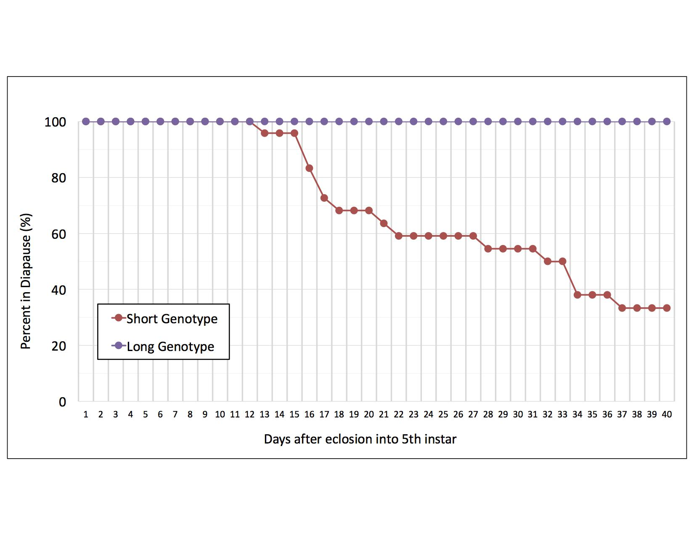

Figure 3-1. Percentage of diapause programmed larvae in diapause across a 40-day trial starting on the rst day of the nal instar. Among long-diapause (purple) genotype individuals, 100% remained larvae throughout the 30-day trial and were classi ed as "deep" diapause larvae. Among the short-diapause genotype individuals (red), 66.6% exited diapause before the end of the trial and classi ed as "shallow" diapause individuals while 33.3% of individuals remained as larvae throughout the 30-day trial and were classi ed as "deep" diapause larvae.

45

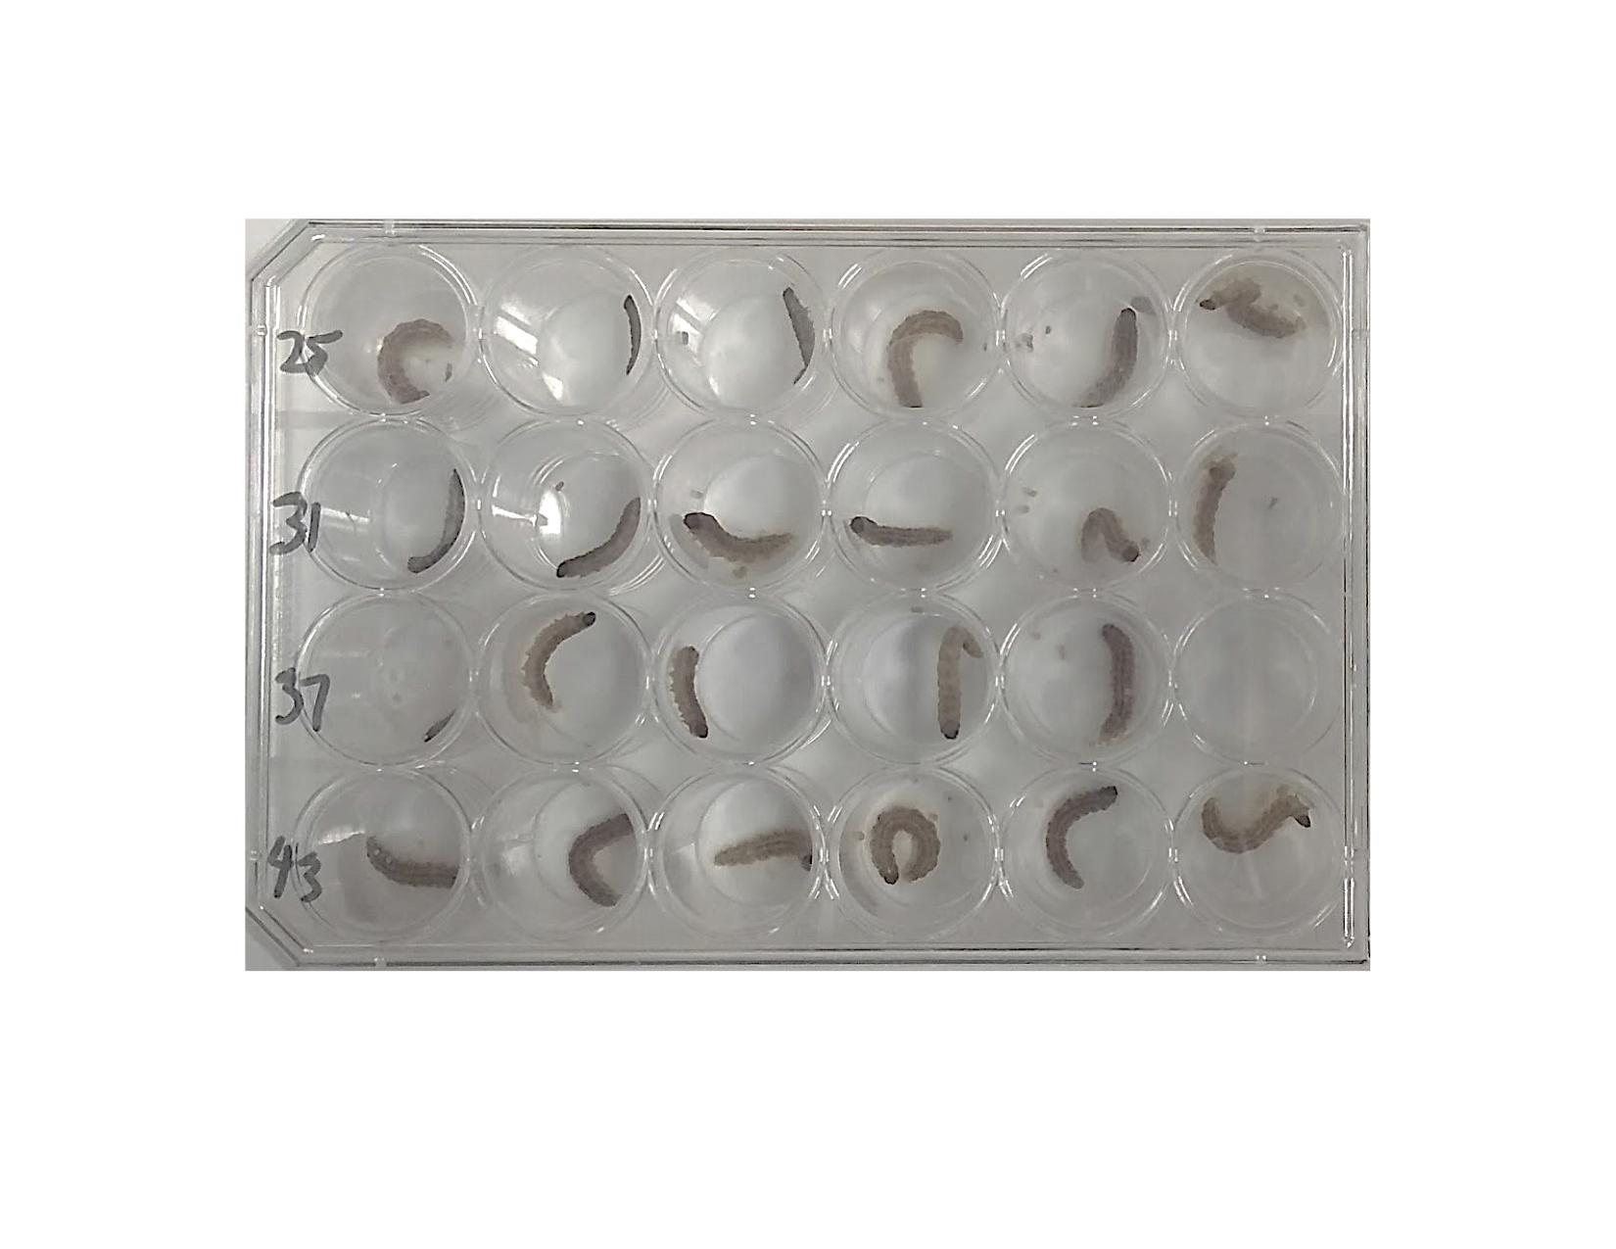

Figure 3-2. 24-well plate used to hold larvae during wandering assay.

46

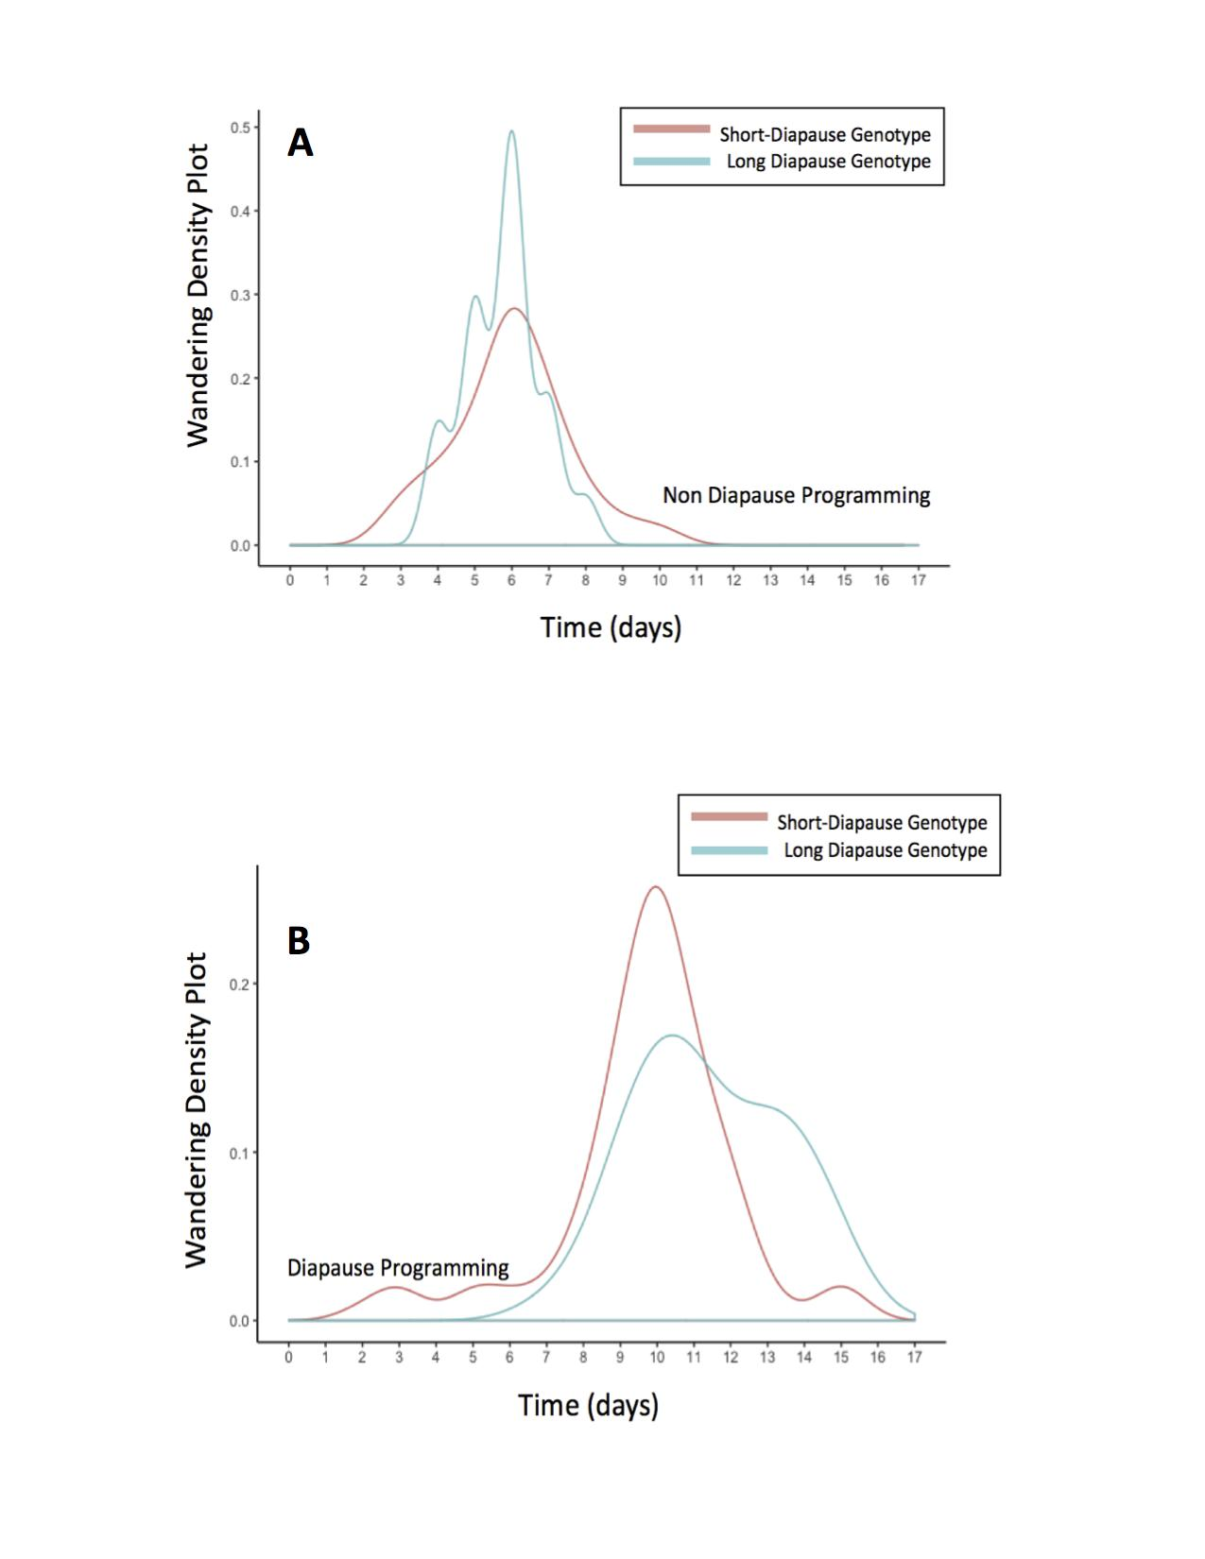

Figure 3-3. Distribution of larvae entering the wandering stage and the number of days after eclosion into the nal larval instar required to reach the wandering stage when reared in non-diapause conditions and diapause programming conditions. Most short-diapause and long-diapause genotype larvae in non-diapause (A) conditions reached the wandering stage six days after eclosing into the nal larval instar. When reared in diapause programming conditions (B), most short-diapause and long diapause genotype larvae reached the wandering stage 10 days after eclosing into the nal larval instar.

47

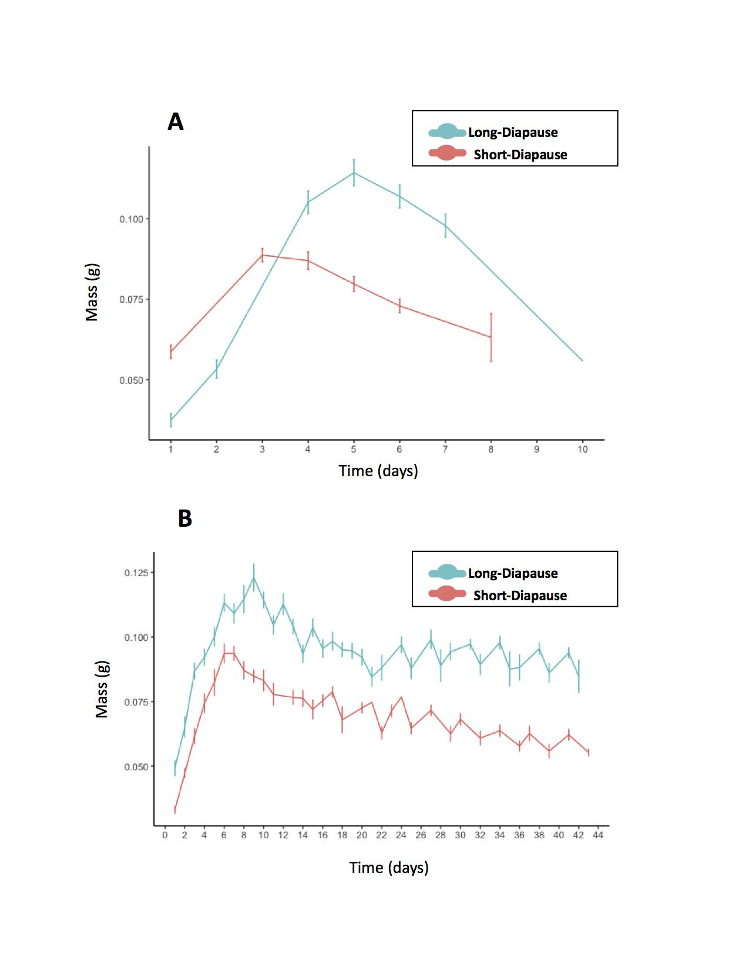

Figure 3-4. The rate of wet mass accumulation among larvae in diapause programming and non- diapause conditions. When reared in non-diapause conditions (A), wet mass peaked in short-diapause genotype larvae (red) 3 days after eclosing into the last larval instar and long-diapause genotype larvae (blue) reached their peak in wet mass 5 days after eclosing into the last larval instar. Among larvae reared in diapause programming condition (B), short-diapause genotype larvae (red) reached their peak in wet mass 6 days after entering the last larval instar while long-diapause genotype larvae (blue) reached their peak in wet mass 9 days after eclosion into the last larval instar.

48

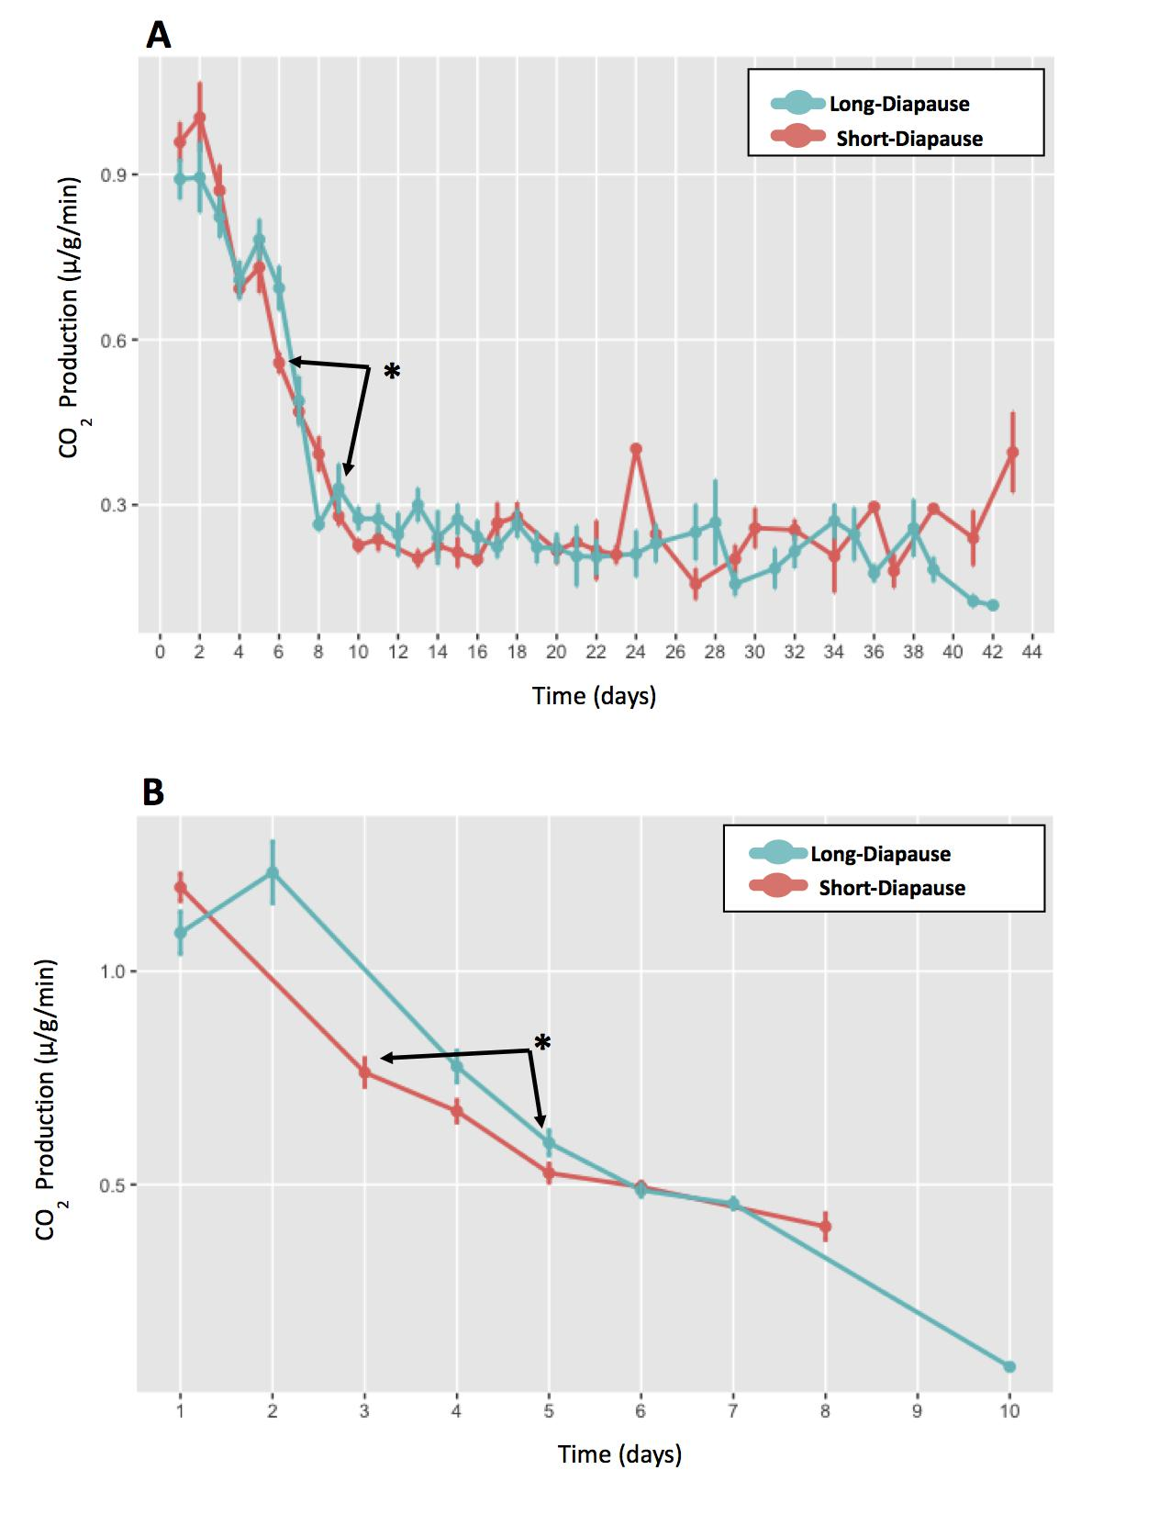

Figure 3-5. Comparing CO2 production of larvae with diﬀerent diapause genotypes reared in the same photoperiod conditions. Co2 production was compared on the day wet mass peaked. Black arrows point towards wet mass peak days and asterisks "*" represent signi cance. (A) Comparing CO2 production between the long-diapause genotype (blue) and the short-diapause genotype (red) in diapause programming conditions. Mass peak days: day-9 for the long-diapause genotype and day-6 for the short diapause genotype. CO2 production at day-9 was signi cantly diﬀerent than day-6 (F-statistic=30.31, Df=26, p-value=8.905e-06). (B) CO2 production comparison between the long-diapause genotype (blue) and the short-diapause genotype (red) in non-diapause conditions. Mass peak days: day-5 for the long-diapause genotype and day-3 for the short diapause genotype. CO2 production was signi cantly diﬀerence on day-5 (F-statistic=13.99, Df=47, p-value=0.0004998)

49

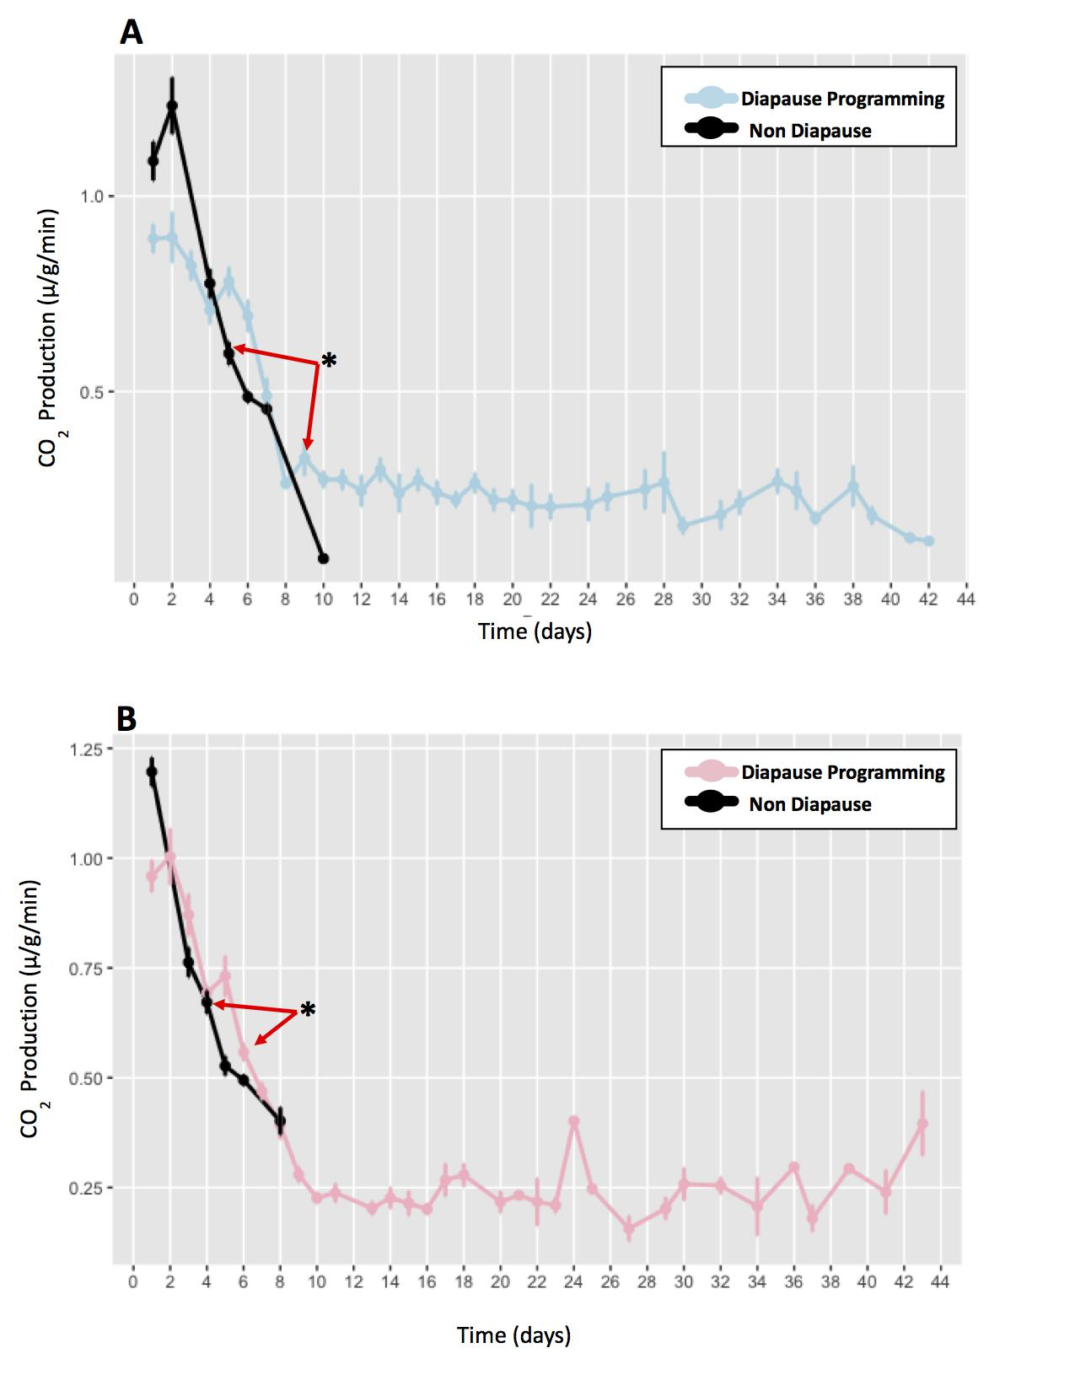

Figure 3-6. Comparing CO2 production among larvae with the same diapause genotype reared in diapause programming and non-diapause conditions. CO2 production was compared on the day wet mass peaked. Red arrows point towards wet mass peak days and asterisks "*" represent signi cance. (A) CO2 production compared between long-diapause genotype larvae in diapause programming conditions (blue) and non- diapause conditions (black). Mass peak days: day-9 reared in diapause programming conditions and day-5 in non diapause conditions. CO2 production in diapause programmed larvae was signi cantly diﬀerent (F-statistic=22.52, DF=30, p-value=4.77e-05). (B) CO2 production compared between short-diapause genotype larvae reared in diapause programming conditions (pink) and non diapause conditions (black). Mass peak days: day-6 in diapause programming conditions and day-3 in non-diapause conditions. CO2 production in diapause programmed larvae was signi cantly diﬀerent (F-statistic=24.91, DF=43,

p-value=1.043e-05).

50

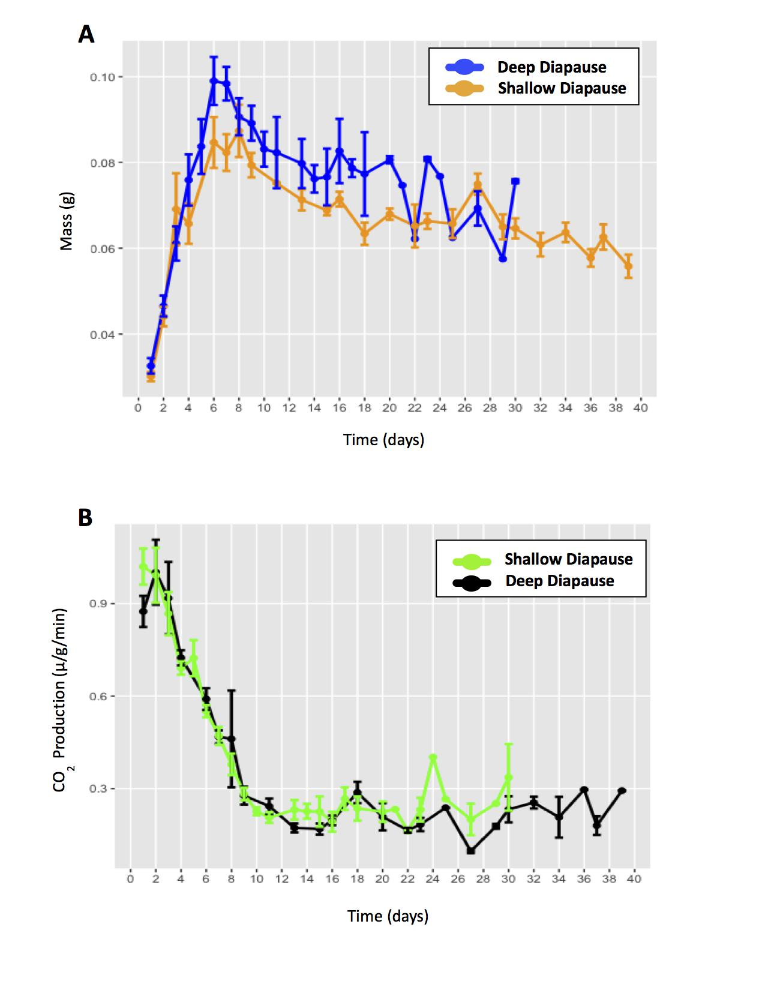

Figure 3-7. Comparing the day wet mass peaked and comparing CO2 production on mass peak day between deep and shallow diapause larvae in diapause programming conditions.

1. Comparing mass peak days between short diapause larvae demonstrating a shallow diapause phenotype (orange) and a deep diapause phenotype (blue). Mass peak days: day-6 for shallow diapause larvae and day-6 for deep diapause larvae.
2. Comparing CO2 production between short-diapause larvae in deep diapause (black) shallow diapause (green). No signi cance diﬀerence in CO2 production between shallow diapause and deep diapause larvae (F-statistic=1.068, DF=14, p-value=0.3189).

51

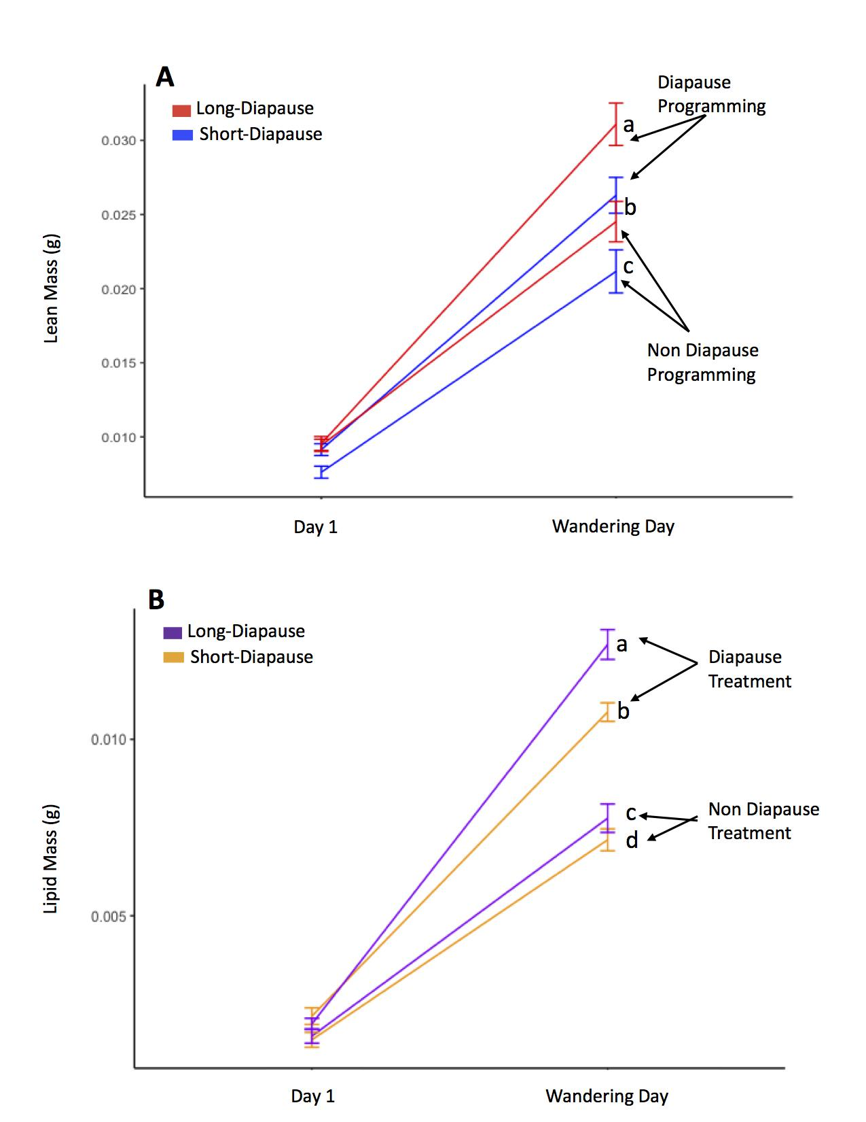

Figure 3-8. Comparing diﬀerences in lean mass and lipid mass accumulation prior to the onset of diapause between individuals reared in diapause programming and non-diapause conditions. Lower case letters represent signi cance. (A) Lean mass accumulation comparison between long-diapause genotype (red) and the short-diapause genotype (blue) individuals prior to the onset of diapause. Lean mass accumulation between individuals reared in diapause programming conditions (a and b) and non-diapause conditions (b and c) was signi cantly eﬀected by diapause genotype (t-value=6.845,Df=10.87, p-value=2.95e-05) and photoperiod (t-value=-9.685, Df=133.3, p-value=<2e-16). (B) Comparing lipid mass accumulation between long-diapause genotype larvae (purple) and short-diapause genotype larvae (orange) prior to the onset of diapause. Lipid mass accumulation between diapause programed individuals (a and b) and individuals in non-diapause conditions (c and d) was signi cantly eﬀected by diapause genotype (t-value=4.08, Df=186.8, p-value=6.67e-05) and photoperiod (t-value=-10.23, Df=191.6, p-value=<2e-16).

52

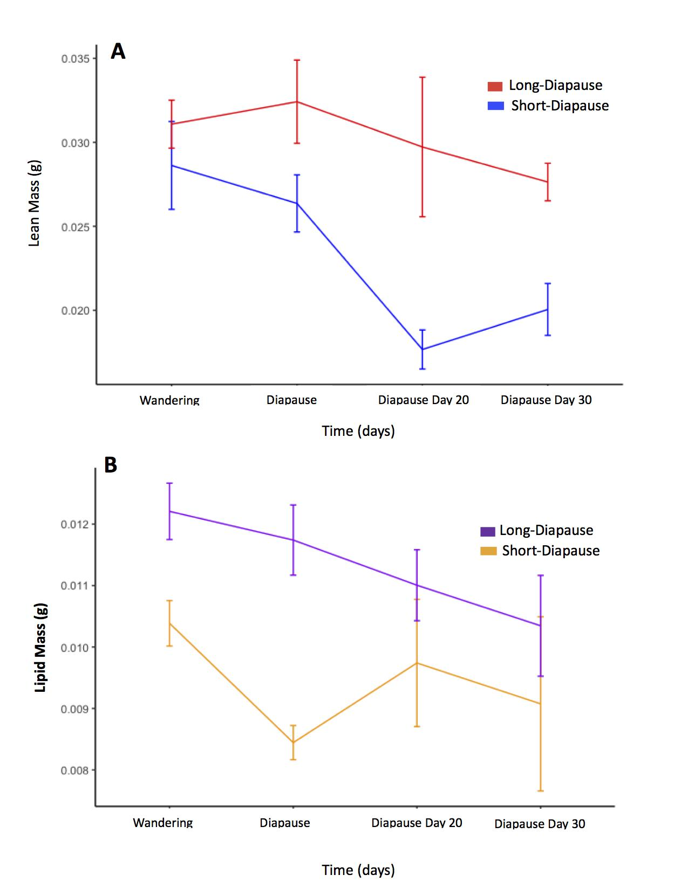

Figure 3-9. Comparing lipid mass depletion and lean mass depletion between individuals reared in diapause programming conditions and non-diapause conditions after the onset of diapause. (A) Comparing lean mass depletion during diapause between the long-diapause genotype (red) and short-diapause genotype (blue). Lean mass depletion during diapause was signi cantly diﬀerent between diapause genotypes (t-value=2.450, Df=10.737, p-value=0.0328). Lean mass did not signi cantly change among larvae within a single diapause genotype during diapause (3-7A,

3-7B). (B) Comparing lipid mass depletion between the long-diapause genotype (purple) and the short diapause genotype (orange). Lipid mass depletion during diapause was signi cantly eﬀected by diapause genotype (t-value=4.735, Df=16.655, p-value=0.000202) and Sample day fteen signi cantly eﬀected lipid mass depletion (t-value=-2.377, Df=14.117, p-value=0.032095). Lipid mass depletion among long-diapause genotype larvae did not signi cantly change during diapause (3-9A). Among short diapause genotype larvae, lipid mass depletion was only signi cantly diﬀerent on day 15 (t-value=-3.877, Df=111.4, p-value=0.000179) (3-9B).

53

Table 3-1. Comparison of CO2 production between diapause genotypes and photoperiods on the day wet mass peaked.

|  |  |  |  |
| --- | --- | --- | --- |
| Model | Df | t value | P |
|  |  |  |  |
|  |  |  |  |
| A). CO2 production between individuals in diapause conditions |  |  |  |
| Diapause Genotype | 26 | -5.505 | 8.9e-06* |
|  |  |  |  |
| B). CO2 production between individuals in non-diapause conditions |  |  |  |
| Diapause Genotype | 47 | -3.74 | 5e-04* |
|  |  |  |  |
| C). CO2 production among long-diapause individuals |  |  |  |
| Photoperiod | 30 | 4.4747 | 4.77e-05* |
|  |  |  |  |
| D). CO2 production among short-diapause individuals |  |  |  |
| Photoperiod | 43 | 4.991 | 1.04e-05* |
|  |  |  |  |
| E). CO2 production between shallow and deep diapause individuals |  |  |  |
| Diapause phenotype | 14 | -1.033 | 0.3189*ns* |
|  |  |  |  |

54

Table 3-2. FULL MODEL: ANOVA summary table for the additive and interactive eﬀects of photoperiod and diapause genotype and the eﬀect of lean mass accumulation. Asterisks "*" indicate statistical signi cance, ns represents non signi cant results.

|  |  |  |  |
| --- | --- | --- | --- |
| Model | Df | F | P |
|  |  |  |  |
| A). Lean mass accumulation on rst day of nal larval instar |  |  |  |
|  |  |  |  |
| Diapause Genotype | 1 | 1.4424 | 0.2331*ns* |
| Photoperiod | 1 | 1.0679 | 0.3043*ns* |
| Diapause Genotype x Photoperiod | 1 | 1.5195 | 0.2211*ns* |
|  |  |  |  |
|  |  |  |  |
| B). Lean mass accumulation on wandering day |  |  |  |
|  |  |  |  |
| Diapause Genotype | 10.87 | 46.858 | 0* |
| Photoperiod | 133.31 | 93.807 | *<*1e-07* |
| Diapause Genotype x Photoperiod | 129.71 | 0.116 | 0.7339*ns* |
|  |  |  |  |

Table 3-3. REDUCED MODEL: Linear mixed eﬀects model table for lean mass accumulation between long-diapause genotype and short-diapause genotype larvae in diapause programming and non-diapause conditions. Asterisks "*" indicate statistical signi cance, ns represents non signi cant.

|  |  |  |  |
| --- | --- | --- | --- |
| Model | Df | t value | P |
|  |  |  |  |
| A). Lean mass on rst day of nal larval instar |  |  |  |
|  |  |  |  |
| Diapause Genotype | 5.93 | 2.034 | 0.0888*ns* |
| Photoperiod | 77.65 | -1.133 | 0.2609*ns* |
|  |  |  |  |
|  |  |  |  |
| B). Lean mass on wandering Day |  |  |  |
|  |  |  |  |
| Diapause Genotype | 10.87 | 6.845 | 2.95e-05* |
| Photoperiod | 133.31 | -9.685 | *<*2e-16* |
|  |  |  |  |

55

Table 3-4. FULL MODEL: ANOVA summary table for the additive and interactive eﬀects of photoperiod and diapause genotype, and the eﬀect of lean mass on lipid mass accumulation. Asterisks "*" indicate statistical signi cance, ns represents non signi cant results.

|  |  |  |  |
| --- | --- | --- | --- |
| Model | Df | F | P |
|  |  |  |  |
|  |  |  |  |
| A). Lipid mass accumulation on rst day of nal larval instar |  |  |  |
|  |  |  |  |
| Diapause Genotype | 77.37 | 0.1563 | 0.6962*ns* |
| Photoperiod | 75.94 | 7.4296 | 0.0080* |
| Lean Mass | 79.61 | 8.6085 | 0.0044* |
| Diapause Genotype x Photoperiod | 74.41 | 0.1673 | 0.6837*ns* |
|  |  |  |  |
| B). Lipid mass accumulation on wandering day |  |  |  |
|  |  |  |  |
| Diapause Genotype | 186.75 | 16.6458 | 1e-04* |
| Photoperiod | 191.57 | 104.74 | *<*1e-07* |
| Lean Mass | 16.25 | 0.0086 | 0.9272*ns* |
| Diapause Genotype x Photoperiod | 186.15 | 1.4634 | 0.2279*ns* |

Table 3-5. REDUCED MODEL: Linear mixed eﬀects model table for lipid mass accumulation between long-diapause genotype and short-diapause genotype larvae in diapause programming and non diapause conditions. Asterisks "*" indicate statistical signi cance, ns represents non signi cant.

|  |  |  |  |
| --- | --- | --- | --- |
| Model | Df | t value | P |
|  |  |  |  |
| A). Lipid mass on rst day of nal larval instar |  |  |  |
|  |  |  |  |
| Lean Mass | 79.61 | 2.934 | 0.00437* |
| Photoperiod | 75.94 | -2.726 | 0.00796* |
|  |  |  |  |
|  |  |  |  |
| B). Lipid mass on wandering day |  |  |  |
|  |  |  |  |
| Diapause Genotype | 186.8 | 4.08 | *<*2e-16* |
| Photoperiod | 191.6 | -10.23 | 6.67e-05* |
|  |  |  |  |

56

Table 3-6. FULL MODEL: ANOVA summary table for the additive and interactive eﬀects of sample day and diapause genotype on lean mass depletion. Asterisks "*" indicate statistical signi cance, ns represents non signi cant results.

|  |  |  |  |
| --- | --- | --- | --- |
| Model | Df | F | P |
|  |  |  |  |
|  |  |  |  |
| Lean mass depletion during the rst 30-days of diapause |  |  |  |
|  |  |  |  |
| Diapause Genotype | 18.73 | 5.9635 | 0.0247* |
| Sample Day | 21.21 | 8.7666 | 0.0002* |
| Diapause Genotype x Sample Day | 9.81 | 1.1885 | 0.3744*ns* |
|  |  |  |  |

Table 3-7. REDUCED MODEL: Linear mixed eﬀects model for lean mass depletion between long-diapause and short-diapause genotypes, among long-diapause genotype larvae, and among short-diapause genotype larvae during diapause. Asterisks "*" indicate statistical signi cance, ns represents non signi cant.

|  |  |  |  |
| --- | --- | --- | --- |
| Model | Df | t value | P |
|  |  |  |  |
| A). Lean mass depletion: Between genotypes |  |  |  |
|  |  |  |  |
| Diapause genotype | 10.737 | 2.450 | 0.0328* |
| Diapause Day 15 | 16.52 | 0.178 | 0.8610*ns* |
| Diapause Day 20 | 15.193 | -0.556 | 0.5864*ns* |
| Diapause Day 30 | 16.004 | -0.683 | 0.5044*ns* |
|  |  |  |  |
|  |  |  |  |
|  |  |  |  |
| A). Lean mass depletion: Long-diapause genotype |  |  |  |
|  |  |  |  |
| Diapause Day 15 | 11.713 | 0.182 | 0.859*ns* |
| Diapause Day 20 | 9.811 | -0.271 | 0.792*ns* |
| Diapause Day 30 | 10.378 | -0.346 | 0.736*ns* |
|  |  |  |  |
|  |  |  |  |
| C). Lean mass depletion: Short-diapause genotype |  |  |  |
|  |  |  |  |
| Diapause Day 15 | 14.133 | -0.267 | 0.793*ns* |
| Diapause Day 20 | 13.621 | -1.095 | 0.292*ns* |
| Diapause Day 30 | 24.952 | -0.997 | 0.328*ns* |
|  |  |  |  |

57

Table 3-8. FULL MODEL: ANOVA summary table for the additive and interactive eﬀects of sample day and diapause genotype, and the eﬀect of lean mass on lipid mass depletion. Asterisks "*" indicate statistical signi cance, ns represents non signi cant results.

|  |  |  |  |
| --- | --- | --- | --- |
| Model | Df | F | P |
|  |  |  |  |
| Lipid mass during the rst 30-days of diapause |  |  |  |
|  |  |  |  |
| Diapause Genotype | 25.31 | 17.4790 | 0.0003* |
| Sample Day | 20.36 | 63.8745 *<*1e-07* | |
| Lean Mass | 37.93 | 1.3748 | 0.2483*ns* |
| Diapause Genotype x Sample Day | 16.13 | 2.0535 | 0.1346*ns* |
|  |  |  |  |

Table 3-9. REDUCED MODEL: Linear mixed eﬀects model for lipid mass depletion between long-diapause genotype and short-diapause genotype larvae, among long-diapause genotype larvae, and short-diapause genotype larvae during diapause. Asterisks "*" indicate statistical signi cance, ns represents non signi cant.

|  |  |  |  |
| --- | --- | --- | --- |
| Model | Df | t value | P |
|  |  |  |  |
|  |  |  |  |
| A). Lipid mass depletion: Between genotypes |  |  |  |
|  |  |  |  |
| Diapause genotype | 16.655 | 4.735 | 0.000202* |
| Diapause Day 15 | 14.117 | -2.377 | 0.03095* |
| Diapause Day 20 | 15.759 | -1.085 | 0.294324*ns* |
| Diapause Day 30 | 15.155 | -1.526 | 0.147622*ns* |
|  |  |  |  |
|  |  |  |  |
| B). Lipid mass depletion: Long-diapause genotype |  |  |  |
|  |  |  |  |
| Diapause Day 15 | 11.87 | -0.376 | 0.714*ns* |
| Diapause Day 20 | 9.366 | -0.902 | 0.389*ns* |
| Diapause Day 30 | 9.851 | -0.740 | 0.476*ns* |
|  |  |  |  |
|  |  |  |  |
| C). Lean mass depletion: Short-diapause genotype |  |  |  |
|  |  |  |  |
| Diapause Day 15 | 111.4 | -3.877 | 0.000179* |
| Diapause Day 20 | 111.4 | 0.752 | 0.453665 |
| Diapause Day 30 | 111.4 | -1.012 | 0.313505 |
|  |  |  |  |

58

REFERENCES

1. S. D. Beck and J. W. Apple, \Eﬀects of Temperature and Photoperiod on Voltinism of Geographical Populations of the European Corn Borer, Pyrausta nubilalis," *Journal* *of economic entomology*, vol. 54, no. 3, pp. 550{558, 1961. [Online]. Available:<https://doi.org/10.1093/jee/54.3.550>
2. C. A. D. De Kort and A. B. Koopmanschap, \Pergamon 0022-1910(93)EOO24-V Nucleotide and Deduced Amino Acid Sequence of a cDNA Clone Encoding Diapause Protein 1, an Arylphorin-type Storage Hexamer of the Colorado Potato Beetle," *J. Insect Physiol*, vol. 40, no. 6, pp. 527{535, 1994. [Online]. Available: [http://ac.els-cdn.com/0022191094901260/](http://ac.els-cdn.com/0022191094901260/1-s2.0-0022191094901260-main.pdf?\\\\\\\%7b_\\\\\\\%7dtid=9aace640-9cde-11e7-98ef-00000aab0f26\\\\\\\%7b&\\\\\\\%7dacdnat=1505786735\\\\\\\%7b_\\\\\\\%7d058c8686475c6f047357c6de4d25b6aa)

[1-s2.0-0022191094901260-main.pdf?](http://ac.els-cdn.com/0022191094901260/1-s2.0-0022191094901260-main.pdf?\\\\\\\\\\\\\\\\\\\\\\\\\\\\\\\\\\\\\\\\\\\\\\\\\\\\\\\\\\\\\\\\\\\\\\\\\\\\\\\\\\\\\\\\\\\\\\\\\\\\\\\\\\\\\\\\\\\\\\\\\\\\\\\\\\\\\\\\\\\\\\\\\\\\\\\\\\\\\\\\\\\\\\\\\\\\\\\\\\\\\\\\\\\\\\\\\\\\\\\\\\\\\\\\\\\\\\\\\\\\\\\\\\\\\\\\\\\\\\\\\\\\\\\\\\\\\\\\\\\\\\\\\\\\\\\\\\\\\\\\\\\\\\\\\\\\\\\\\\\\\\\\\\\\\\\\\\\\\\\\\\\\\\\\\\\\\\\\\\\\\\\\\\\\\\\\\\\\\\\\\\\\\\\\\\\\\\\\\\\\\\\\\\\\\\\\\\\\\\\\\\\\\\\\\\\\\\\\\\\\\\\\\\\\\\\\\\\\\\\\\\\\\\\\\\\\\\\\\\\\\\\\\\\\\\\\\\\\\\\\\\\\\\\\\\\\\\\\\\\\\\\\\\\\\\\\\\\\\\\\\\\\\\\\\\\\\\\\\\\\\\\\\\\\\\\\\\\\\\\\\\\\\\\\\\\\\\\\\\\\\\\\\\\\\\\\\\\\\\\\\\\\\\\\\\\\\\\\\\\\\\\\\\\\\\\\\\\\\\\\\\\\\\\\\\\\\\\\\\\\\\\\\\\\\\\\\\\\\\\\\\\\\\\\\\\\\\\\\\\\\\\\\\\\\\\\\\\\\\\\\\\\\\\\\\\\\\\\\\\\\\\\\\\\\\\\\\\\\\\\\\\\\\\\\\\\\\\\\\\\\\\\\\\\\\\\\\\\\\\\\\\\\\\\\\\\\\\\\\\\\\\\\\\\\\\\\\\\\\\\\\\\\\\\\\\\\\\\\\\\\\\\\\\\\\\\\\\\\\\\\\\\\\\\\\\\\\\\\\\\\\\\\\\\\\\\\\\\\\\\\\\\\\\\\\\\\\\\\\\\\\\\\\\\\\\\\\\\\\\\\\\\\\\\\\\\\\\\\\\\\\\\\\\\\\\\\\\\\\\\\\\\\\\\\\\\\\\\\\\\\\\\\\\\\\\\\\\\\\\\\\\\\\\\\\\\\\\\\\\\\\\\\\\\\\\\\\\\\\\\\\\\\\\\\\\\\\\\\\\\\\\\\\\\\\\\\\\\\\\\\\\\\\\\\\\\\\\\\\\\\\\\\\\\\\\\\\\\\\\\\\\\\\\\\\\\\\\\\\\\\\\\\\\\\\\\\\\\\\\\\\\\\\\\\\\\\\\\\\\\\\\\\\\\\\\\\\\\\\\\\\\\\\\\\\\\\\\\\\\\\\\\\\\\\\\\\\\\\\\\\\\\\\\\\\\\\\\\\\\\\\\\\\\\\\\\\\\\\\\\\\\\\\\\\\\\\\\\\\\\\\\\\\\\\\\\\\\\\\\\\\\\\\\\\\\\\\\\\\\\\\\\\\\\\\\\\\\\\\\\\\\\\\\\\\\\\\\\\\\\\\\\\\\\\\\\\\\\\\\\\\\\\\\\\\\\\\\\\\\\\\\\\\\\\\\\\\\\\\\\\\\\\\\\\\\\\\\\\\\\\\\\\\\\\\\\\\\\\\\\\\\\\\\\\\\\\\\\\\\\\\\\\\\\\\\\\\\\\\\\\\\\\\\\\\\\\\\\\\\\\\\\\\\\\\\\\\\\\\\\\\\\\\\\\\\\\\\\\\\\\\\\\\\\\\\\\\\\\\\\\\\\\\\\\\\\\\\\\\\\\\\\\\\\\\\\\\\\\\\\\\\\\\\\\\\\\\\\\\\\\\\\\\\\\\\\\\\\\\\\\\\\\\\\\\\\\\\\\\\\\\\\\\\\\\\\\\\\\\\\\\\\\\\\\\\\\\\\\\\\\\\\\\\\\\\\\\\\\\\\\\\\\\\\\\\\\\\\\\\\\\\\\\\\\\\\\\\\\\\\\\\\\\\\\\\\\\\\\\\\\\\\\\\\\\\\\\\\\\\\\\\\\\\\\\\\\\\\\\\\\\\\\\\\\\\\\\\\\\\\\\\\\\\\\\\\\\\\\\\\\\\\\\\\\\\\\\\\\\\\\\\\\\\\\\\\\\\\\\\\\\\\\\\\\\\\\\\\\\\\\\\\\\\\\\\\)*f* *g*[tid=9aace640-9cde-11e7-98ef-00000aab0f26](http://ac.els-cdn.com/0022191094901260/1-s2.0-0022191094901260-main.pdf?\\\\\\\\\\\\\\\\\\\\\\\\\\\\\\\\\\\\\\\\\\\\\\\\\\\\\\\\\\\\\\\\\\\\\\\\\\\\\\\\\\\\\\\\\\\\\\\\\\\\\\\\\\\\\\\\\\\\\\\\\\\\\\\\\\\\\\\\\\\\\\\\\\\\\\\\\\\\\\\\\\\\\\\\\\\\\\\\\\\\\\\\\\\\\\\\\\\\\\\\\\\\\\\\\\\\\\\\\\\\\\\\\\\\\\\\\\\\\\\\\\\\\\\\\\\\\\\\\\\\\\\\\\\\\\\\\\\\\\\\\\\\\\\\\\\\\\\\\\\\\\\\\\\\\\\\\\\\\\\\\\\\\\\\\\\\\\\\\\\\\\\\\\\\\\\\\\\\\\\\\\\\\\\\\\\\\\\\\\\\\\\\\\\\\\\\\\\\\\\\\\\\\\\\\\\\\\\\\\\\\\\\\\\\\\\\\\\\\\\\\\\\\\\\\\\\\\\\\\\\\\\\\\\\\\\\\\\\\\\\\\\\\\\\\\\\\\\\\\\\\\\\\\\\\\\\\\\\\\\\\\\\\\\\\\\\\\\\\\\\\\\\\\\\\\\\\\\\\\\\\\\\\\\\\\\\\\\\\\\\\\\\\\\\\\\\\\\\\\\\\\\\\\\\\\\\\\\\\\\\\\\\\\\\\\\\\\\\\\\\\\\\\\\\\\\\\\\\\\\\\\\\\\\\\\\\\\\\\\\\\\\\\\\\\\\\\\\\\\\\\\\\\\\\\\\\\\\\\\\\\\\\\\\\\\\\\\\\\\\\\\\\\\\\\\\\\\\\\\\\\\\\\\\\\\\\\\\\\\\\\\\\\\\\\\\\\\\\\\\\\\\\\\\\\\\\\\\\\\\\\\\\\\\\\\\\\\\\\\\\\\\\\\\\\\\\\\\\\\\\\\\\\\\\\\\\\\\\\\\\\\\\\\\\\\\\\\\\\\\\\\\\\\\\\\\\\\\\\\\\\\\\\\\\\\\\\\\\\\\\\\\\\\\\\\\\\\\\\\\\\\\\\\\\\\\\\\\\\\\\\\\\\\\\\\\\\\\\\\\\\\\\\\\\\\\\\\\\\\\\\\\\\\\\\\\\\\\\\\\\\\\\\\\\\\\\\\\\\\\\\\\\\\\\\\\\\\\\\\\\\\\\\\\\\\\\\\\\\\\\\\\\\\\\\\\\\\\\\\\\\\\\\\\\\\\\\\\\\\\\\\\\\\\\\\\\\\\\\\\\\\\\\\\\\\\\\\\\\\\\\\\\\\\\\\\\\\\\\\\\\\\\\\\\\\\\\\\\\\\\\\\\\\\\\\\\\\\\\\\\\\\\\\\\\\\\\\\\\\\\\\\\\\\\\\\\\\\\\\\\\\\\\\\\\\\\\\\\\\\\\\\\\\\\\\\\\\\\\\\\\\\\\\\\\\\\\\\\\\\\\\\\\\\\\\\\\\\\\\\\\\\\\\\\\\\\\\\\\\\\\\\\\\\\\\\\\\\\\\\\\\\\\\\\\\\\\\\\\\\\\\\\\\\\\\\\\\\\\\\\\\\\\\\\\\\\\\\\\\\\\\\\\\\\\\\\\\\\\\\\\\\\\\\\\\\\\\\\\\\\\\\\\\\\\\\\\\\\\\\\\\\\\\\\\\\\\\\\\\\\\\\\\\\\\\\\\\\\\\\\\\\\\\\\\\\\\\\\\\\\\\\\\\\\\\\\\\\\\\\\\\\\\\\\\\\\\\\\\\\\\\\\\\\\\\\\\\\\\\\\\\\\\\\\\\\\\\\\\\\\\\\\\\\\\\\\\\\\\\\\\\\\\\\\\\\\\\\\\\\\\\\\\\\\\\\\\\\\\\\\\\\\\\\\\\\\\\\\\\\\\\\\\\\\\\\\\\\\\\\\\\\\\\\\\\\\\\\\\\\\\\\\\\\\\\\\\\\\\\\\\\\\\\\\\\\\\\\\\\\\\\\\\\\\\\\\\\\\\\\\\\\\\\\\\\\\\\\\\\\\\\\\\\\\\\\\\\\\\\\\\\\\\\\\\\\\\\\\\\\\\\\\\\\\\\\\\\\\\\\\\\\\\\\\\\\\\\\\\\\\\\\\\\\\\\\\\\\\\\\\\\\\\\\\\\\\\\\\\\\\\\\\\\\\\\\\\\\\\\\\\\\\\\\\\\\\)*f*[&](http://ac.els-cdn.com/0022191094901260/1-s2.0-0022191094901260-main.pdf?\\\\\\\\\\\\\\\\\\\\\\\\\\\\\\\\\\\\\\\\\\\\\\\\\\\\\\\\\\\\\\\\\\\\\\\\\\\\\\\\\\\\\\\\\\\\\\\\\\\\\\\\\\\\\\\\\\\\\\\\\\\\\\\\\\\\\\\\\\\\\\\\\\\\\\\\\\\\\\\\\\\\\\\\\\\\\\\\\\\\\\\\\\\\\\\\\\\\\\\\\\\\\\\\\\\\\\\\\\\\\\\\\\\\\\\\\\\\\\\\\\\\\\\\\\\\\\\\\\\\\\\\\\\\\\\\\\\\\\\\\\\\\\\\\\\\\\\\\\\\\\\\\\\\\\\\\\\\\\\\\\\\\\\\\\\\\\\\\\\\\\\\\\\\\\\\\\\\\\\\\\\\\\\\\\\\\\\\\\\\\\\\\\\\\\\\\\\\\\\\\\\\\\\\\\\\\\\\\\\\\\\\\\\\\\\\\\\\\\\\\\\\\\\\\\\\\\\\\\\\\\\\\\\\\\\\\\\\\\\\\\\\\\\\\\\\\\\\\\\\\\\\\\\\\\\\\\\\\\\\\\\\\\\\\\\\\\\\\\\\\\\\\\\\\\\\\\\\\\\\\\\\\\\\\\\\\\\\\\\\\\\\\\\\\\\\\\\\\\\\\\\\\\\\\\\\\\\\\\\\\\\\\\\\\\\\\\\\\\\\\\\\\\\\\\\\\\\\\\\\\\\\\\\\\\\\\\\\\\\\\\\\\\\\\\\\\\\\\\\\\\\\\\\\\\\\\\\\\\\\\\\\\\\\\\\\\\\\\\\\\\\\\\\\\\\\\\\\\\\\\\\\\\\\\\\\\\\\\\\\\\\\\\\\\\\\\\\\\\\\\\\\\\\\\\\\\\\\\\\\\\\\\\\\\\\\\\\\\\\\\\\\\\\\\\\\\\\\\\\\\\\\\\\\\\\\\\\\\\\\\\\\\\\\\\\\\\\\\\\\\\\\\\\\\\\\\\\\\\\\\\\\\\\\\\\\\\\\\\\\\\\\\\\\\\\\\\\\\\\\\\\\\\\\\\\\\\\\\\\\\\\\\\\\\\\\\\\\\\\\\\\\\\\\\\\\\\\\\\\\\\\\\\\\\\\\\\\\\\\\\\\\\\\\\\\\\\\\\\\\\\\\\\\\\\\\\\\\\\\\\\\\\\\\\\\\\\\\\\\\\\\\\\\\\\\\\\\\\\\\\\\\\\\\\\\\\\\\\\\\\\\\\\\\\\\\\\\\\\\\\\\\\\\\\\\\\\\\\\\\\\\\\\\\\\\\\\\\\\\\\\\\\\\\\\\\\\\\\\\\\\\\\\\\\\\\\\\\\\\\\\\\\\\\\\\\\\\\\\\\\\\\\\\\\\\\\\\\\\\\\\\\\\\\\\\\\\\\\\\\\\\\\\\\\\\\\\\\\\\\\\\\\\\\\\\\\\\\\\\\\\\\\\\\\\\\\\\\\\\\\\\\\\\\\\\\\\\\\\\\\\\\\\\\\\\\\\\\\\\\\\\\\\\\\\\\\\\\\\\\\\\\\\\\\\\\\\\\\\\\\\\\\\\\\\\\\\\\\\\\\\\\\\\\\\\\\\\\\\\\\\\\\\\\\\\\\\\\\\\\\\\\\\\\\\\\\\\\\\\\\\\\\\\\\\\\\\\\\\\\\\\\\\\\\\\\\\\\\\\\\\\\\\\\\\\\\\\\\\\\\\\\\\\\\\\\\\\\\\\\\\\\\\\\\\\\\\\\\\\\\\\\\\\\\\\\\\\\\\\\\\\\\\\\\\\\\\\\\\\\\\\\\\\\\\\\\\\\\\\\\\\\\\\\\\\\\\\\\\\\\\\\\\\\\\\\\\\\\\\\\\\\\\\\\\\\\\\\\\\\\\\\\\\\\\\\\\\\\\\\\\\\\\\\\\\\\\\\\\\\\\\\\\\\\\\\\\\\\\\\\\\\\\\\\\\\\\\\\\\\\\\\\\\\\\\\\\\\\\\\\\\\\\\\\\\\\\\\\\\\\\\\\\\\\\\\\\\\\\\\\\\\\\\\\\\\\\\\\\\\\\\\\\\\\\\\\\\\\\\\\\\\\\\\\\\\\\\\\\\\\\\\\\\\\\\\\\\\\\\\\\\\\\\\\\\\\\\\\\\\\\\\\\\\\\\\\\\\\\\\\\\\\\\\\\\\)*g* [acdnat=1505786735](http://ac.els-cdn.com/0022191094901260/1-s2.0-0022191094901260-main.pdf?\\\%7b_\\\%7dtid=9aace640-9cde-11e7-98ef-00000aab0f26\\\%7b&\\\%7dacdnat=1505786735\\\%7b_\\\%7d058c8686475c6f047357c6de4d25b6aa)*f* *g*[058c8686475c6f047357c6de4d25b6aa](http://ac.els-cdn.com/0022191094901260/1-s2.0-0022191094901260-main.pdf?\\\%7b_\\\%7dtid=9aace640-9cde-11e7-98ef-00000aab0f26\\\%7b&\\\%7dacdnat=1505786735\\\%7b_\\\%7d058c8686475c6f047357c6de4d25b6aa)

1. C. J. Mitchell and H. Briegel, \Inability of diapausing Culex pipiens (Diptera: Culicidae) to use blood for producing lipid reserves for overwinter survival." *Journal* *of medical entomology*, vol. 26, no. 4, pp. 318{26, 1989. [Online]. Available:<http://www.ncbi.nlm.nih.gov/pubmed/2769712>
2. C. Parmesan, \Ecological and Evolutionary Responses to Recent Climate Change," *Annual* *Review of Ecology, Evolution, and Systematics*, vol. 37, no. 1, pp. 637{669, 2006. [Online].Available: <http://www.annualreviews.org/doi/10.1146/annurev.ecolsys.37.091305.110100>
3. ||, \Ecological and Evolutionary Responses to Recent Climate Change," *Annual Review* *of Ecology, Evolution, and Systematics*, vol. 37, no. 1, pp. 637{669, dec 2006. [Online].Available: <http://www.annualreviews.org/doi/10.1146/annurev.ecolsys.37.091305.110100>
4. C. A. Deutsch, J. J. Tewksbury, R. B. Huey, K. S. Sheldon, C. K. Ghalambor, D. C. Haak, and P. R. Martin, \Impacts of climate warming on terrestrial ectotherms across latitude," *Proceedings of the National Academy of Sciences*, vol. 105, no. 18, pp. 6668{6672,

2008. [Online]. Available: www.pnas.org?cgi?doi?10.1073?pnas.0709472105http: //www.pnas.org/cgi/doi/10.1073/pnas.0709472105

59

1. S. E. Williams, L. P. Shoo, J. L. Isaac, A. A. Hoﬀmann, and G. Langham, \Towards an Integrated Framework for Assessing the Vulnerability of Species to Climate Change," *PLoS Biology*, vol. 6, no. 12, p. e325, 2008. [Online]. Available: <http://dx.plos.org/10.1371/journal.pbio.0060325>
2. D. A. Hahn and D. L. Denlinger, \Meeting the energetic demands of insect diapause: Nutrient storage and utilization," *Journal of Insect Physiology*, vol. 53, no. 8, pp. 760{773, 2007.
3. L. Hughes, \Biological consequences of global warming: Is the signal already apparent?" *Trends in Ecology and Evolution*, vol. 15, no. 2, pp. 56{61, 2000.
4. A. A. Agrawal, \Phenotypic Plasticity in the Interactions and Evolution of Species," *Science*, vol. 294, no. 5541, pp. 321{326, 2001. [Online]. Available: <http://www.sciencemag.org/cgi/doi/10.1126/science.1060701>
5. C. E. Lee, \Evolutionary genetics of invasive species," *Trends in Ecology* *and Evolution*, vol. 17, no. 8, pp. 386{391, 2002. [Online]. Available:<http://linkinghub.elsevier.com/retrieve/pii/S0169534702025545>
6. NOAA National Centers for Environmental Information, \State of the Climate: Global Climate Report for Annual 2016," 2017. [Online]. Available: <https://www.ncdc.noaa.gov/sotc/global/201613>
7. C. Parmesan, N. Ryrholm, C. Stefanescu, J. K. Hill, C. D. Thomas, H. Descimon, B. Huntley, L. Kaila, J. Kullberg, T. Tammaru, W. J. Tennent, J. a. Thomas, and M. Warren, \Poleward shifts in geographical ranges of butter y species associated with regional warming," *Nature*, vol. 399, no. June, pp. 579{583, 1999. [Online]. Available: <http://eprints.whiterose.ac.uk/54320/>
8. E. B. Dopman, L. Perez, S. M. Bogdanowicz, and R. G. Harrison, \Consequences of reproductive barriers for genealogical discordance in the European corn borer," *Proceedings* *of the National Academy of Sciences*, vol. 102, no. 41, pp. 14 706{14 711, 2005. [Online].Available: <http://www.pnas.org/cgi/doi/10.1073/pnas.0502054102>

60

1. N. Haunerland, \Storage Protein Receptors."
2. E. B. Dopman, P. S. Robbins, and A. Seaman, \Components of reproductive isolation between north american pheromone strains of the european corn borer," *Evolution*, vol. 64, no. 4, pp. 881{902, 2010.
3. D. A. Hahn and D. L. Denlinger, \Energetics of Insect Diapause," *Annual* *Review of Entomology*, vol. 56, no. 1, pp. 103{121, 2011. [Online]. Available:<http://www.annualreviews.org/doi/10.1146/annurev-ento-112408-085436>
4. E. H. DeLucia, C. L. Casteel, P. D. Nabity, and B. F. O'Neill, \Insects take a bigger bite out of plants in a warmer, higher carbon dioxide world," *Proceedings of the* *National Academy of Sciences*, vol. 105, no. 6, pp. 1781{1782, 2008. [Online]. Available:<http://www.pnas.org/cgi/doi/10.1073/pnas.0712056105>
5. B. J. Sinclair, \Linking energetics and overwintering in temperate insects," *Journal of Thermal Biology*, vol. 54, pp. 5{11, 2015. [Online]. Available:<http://dx.doi.org/10.1016/j.jtherbio.2014.07.007>
6. C. M. Williams, H. A. Henry, and B. J. Sinclair, \Cold truths: How winter drives responses of terrestrial organisms to climate change," *Biological Reviews*, vol. 90, no. 1, pp. 214{235, 2015.
7. E. L. Arrese and J. L. Soulages, \Insect Fat Body: Energy, Metabolism, and Regulation," *Annual Review of Entomology*, vol. 55, no. 1, pp. 207{225, 2010. [Online]. Available:<http://www.annualreviews.org/doi/10.1146/annurev-ento-112408-085356>
8. J. S. Bale and S. A. L. Hayward, \Insect overwintering in a changing climate," *Journal of Experimental Biology*, vol. 213, no. 6, pp. 980{994, 2010. [Online]. Available:<http://jeb.biologists.org/cgi/doi/10.1242/jeb.037911>
9. W. E. Bradshaw and C. M. Holzapfel, \Evolutionary response to rapid climate change," *Science*, vol. 312, no. 5779, pp. 1477{1478, 2006.
10. G. A. Breed, S. Stichter, and E. E. Crone, \Climate-driven changes in northeastern US butter y communities," *Nature Climate Change*, vol. 3, no. 2, pp. 142{145, 2012. [Online].

61

Available: [http://www.nature.com/doi nder/10.1038/nclimate1663](http://www.nature.com/doifinder/10.1038/nclimate1663)

1. J. M. Scriber, *Climate-driven reshuﬄing of species and genes: Potential conservation roles* *for species translocations and recombinant hybrid genotypes*, 2014, vol. 5, no. 1.
2. R. A. Hut, S. Paolucci, R. Dor, C. P. Kyriacou, and S. Daan, \Latitudinal clines: an

evolutionary view on biological rhythms," *Proceedings of the Royal Society B: Biological* *Sciences*, vol. 280, no. 1765, pp. 20 130 433{20 130 433, 2013. [Online]. Available:<http://rspb.royalsocietypublishing.org/cgi/doi/10.1098/rspb.2013.0433>

1. J. L. E. Capinera and N. Department), \European corn borer scienti c name : Ostrinia

nubilalis ( H•ubner ) ( Insecta : Lepidoptera : Pyralidae )," 2000. [Online]. Available: [http://entnemdept.u .edu/creatures/ eld/e](http://entnemdept.ufl.edu/creatures/field/e\\\\\\\\\\\\\\\\\\\\\\\\\\\\\\\\\\\\\\\\\\\\\\\\\\\\\\\\\\\\\\\%7b_\\\\\\\\\\\\\\\\\\\\\\\\\\\\\\\\\\\\\\\\\\\\\\\\\\\\\\\\\\\\\\\%7dcorn\\\\\\\\\\\\\\\\\\\\\\\\\\\\\\\\\\\\\\\\\\\\\\\\\\\\\\\\\\\\\\\%7b_\\\\\\\\\\\\\\\\\\\\\\\\\\\\\\\\\\\\\\\\\\\\\\\\\\\\\\\\\\\\\\\%7dborer.htm)*f* *g*[corn](http://entnemdept.ufl.edu/creatures/field/e\\\\\\\\\\\\\\\\\\\\\\\\\\\\\\\\\\\\\\\\\\\\\\\\\\\\\\\\\\\\\\\%7b_\\\\\\\\\\\\\\\\\\\\\\\\\\\\\\\\\\\\\\\\\\\\\\\\\\\\\\\\\\\\\\\%7dcorn\\\\\\\\\\\\\\\\\\\\\\\\\\\\\\\\\\\\\\\\\\\\\\\\\\\\\\\\\\\\\\\%7b_\\\\\\\\\\\\\\\\\\\\\\\\\\\\\\\\\\\\\\\\\\\\\\\\\\\\\\\\\\\\\\\%7dborer.htm)*f* *g*[borer.htm](http://entnemdept.ufl.edu/creatures/field/e\\\\\\\\\\\\\\\\\\\\\\\\\\\\\\\\\\\\\\\\\\\\\\\\\\\\\\\\\\\\\\\%7b_\\\\\\\\\\\\\\\\\\\\\\\\\\\\\\\\\\\\\\\\\\\\\\\\\\\\\\\\\\\\\\\%7dcorn\\\\\\\\\\\\\\\\\\\\\\\\\\\\\\\\\\\\\\\\\\\\\\\\\\\\\\\\\\\\\\\%7b_\\\\\\\\\\\\\\\\\\\\\\\\\\\\\\\\\\\\\\\\\\\\\\\\\\\\\\\\\\\\\\\%7dborer.htm)

1. C. B. Wadsworth, X. Li, and E. B. Dopman, \A recombination suppressor contributes to ecological speciation in OSTRINIA moths," *Heredity*, vol. 114, no. 6, pp. 593{600, 2015. [Online]. Available: [http://www.nature.com/doi nder/10.1038/hdy.2014.128](http://www.nature.com/doifinder/10.1038/hdy.2014.128)
2. C. A. Tauber and M. J. Tauber, \Insect seasonal cycles: genetics and evolution ,~4195," vol. 12, no. 1981, pp. 281{308, 1981.
3. J. C. Regier, C. Mitter, M. A. Solis, J. E. Hayden, B. Landry, M. Nuss, T. J. Simonsen, S. H. Yen, A. Zwick, and M. P. Cummings, \A molecular phylogeny for the pyraloid moths (Lepidoptera: Pyraloidea) and its implications for higher-level classi cation," *Systematic* *Entomology*, vol. 37, no. 4, pp. 635{656, 2012.
4. D. B. Gelman and D. K. Hayes, \Methods and Markers for Synchronizing Maturation of Fifth-Stage Larvae and Pupae of the European Corn Borer , Ostrinia nubilalis," *Ann.* *Entomol. Soc.*, vol. 75, no. 5, pp. 485{493, 1982.
5. S. L. Mo, \Safety Data Sheet on Nitric Acid," *Industrial & Engineering* *Chemistry*, vol. 40, no. 10, pp. 1945{1945, 1948. [Online]. Available:<http://pubs.acs.org/doi/abs/10.1021/ie50466a600>
6. S. D. Beck, \Diapause in the European Corn Borer , Pyrausta," vol. 4, pp. 304{318, 1960.

62

1. S. L. Chown, \Physiological diversity in insects:ecology and evolutionary contexts," *Advances in insect physiology*, vol. 33, pp. 50{152, 2007.
2. V. Kostal, \Eco-physiological phases of insect diapause," *Journal of Insect Physiology*, vol. 52, no. 2, pp. 113{127, 2006.
3. J. Hyde, M. A. Martin, P. V. Preckel, and C. R. Edwards, \The economics of Bt corn: valuing protection from the European Corn Borer," *Review of* *Agricultural Economics*, vol. 21, no. 2, pp. 442{454, 1999. [Online]. Available:<http://aepp.oxfordjournals.org/content/21/2/442>
4. A. D. Gossert, A. Hinniger, S. Gutmann, W. Jahnke, A. Strauss, and C. Fernandez, \A simple protocol for amino acid type selective isotope labeling in insect cells with improved yields and high reproducibility," pp. 449{456, 2011. [Online]. Available: <http://www.jbc.org/content/226/1/497.short>
5. J. S. Bale, G. J. Masters, I. D. Hodkinson, C. Awmack, T. M. Bezemer, V. K. Brown, J. Butter eld, A. Buse, J. C. Coulson, J. Farrar, J. E. Good, R. Harrington, S. Hartley, T. H. Jones, R. L. Lindroth, M. C. Press, I. Symrnioudis, A. D. Watt, and J. B. Whittaker, \Herbivory in global climate change research: Direct eﬀects of rising temperature on insect herbivores," *Global Change Biology*, vol. 8, no. 1, pp. 1{16, 2002.
6. W. E. Bradshaw and C. M. Holzapfel, \Genetic shift in photoperiodic response correlated with global warming." *Proceedings of the National Academy of Sciences of the* *United States of America*, vol. 98, no. 25, pp. 14 509{14 511, 2001. [Online]. Available:<http://www.pnas.org/cgi/doi/10.1073/pnas.241391498>
7. R. C. Levy, G. M. Kozak, C. B. Wadsworth, B. S. Coates, and E. B. Dopman, \Explaining the sawtooth: Latitudinal periodicity in a circadian gene correlates with shifts in generation number," *Journal of Evolutionary Biology*, vol. 28, no. 1, pp. 40{53, 2015.

63

BIOGRAPHICAL SKETCH

James Brown, a Florida native, was born in 1984 in Ft. Lauderdale, Florida and grew up in West Palm Beach, Florida. James grew up curious about the biology of the natural world and leading him to pursue a secondary school education in biological science. At the University of Maryland, College Park, James majored in biological sciences with a concentration in Cell Biology and Molecular Genetics. James received his Bachelor of Biological Science in 2010 and began working in the Insect Behavior and Biological Control Unit of the USDA-ARS CMAVE in Gainesville, Florida before starting his Master's degree. James received his Master's degree in Entomology at the University of Florida in August 2018, and is expected to pursue a Ph.D in Entomology.

64